Mini Project 2
Folded Cascode Fully Differential Amplifier
With CMFB

Part 1: gm/ID Design Charts
NMOS Charts:
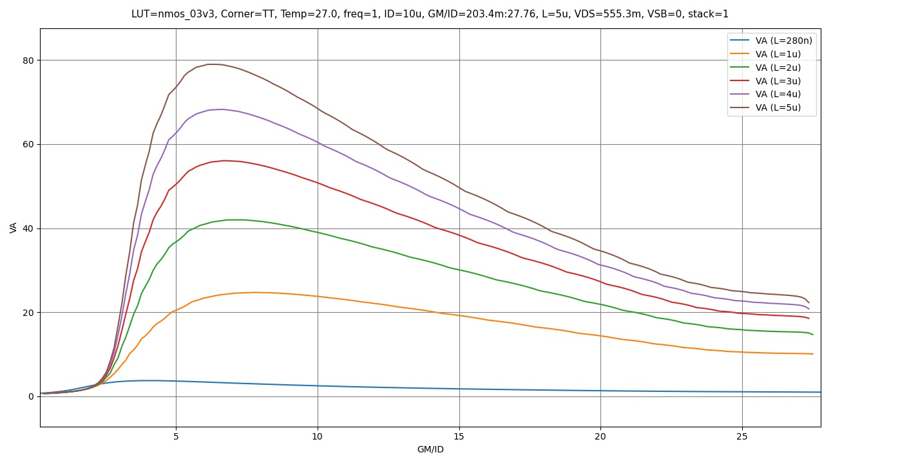
Figure 1 VA vs gm/id
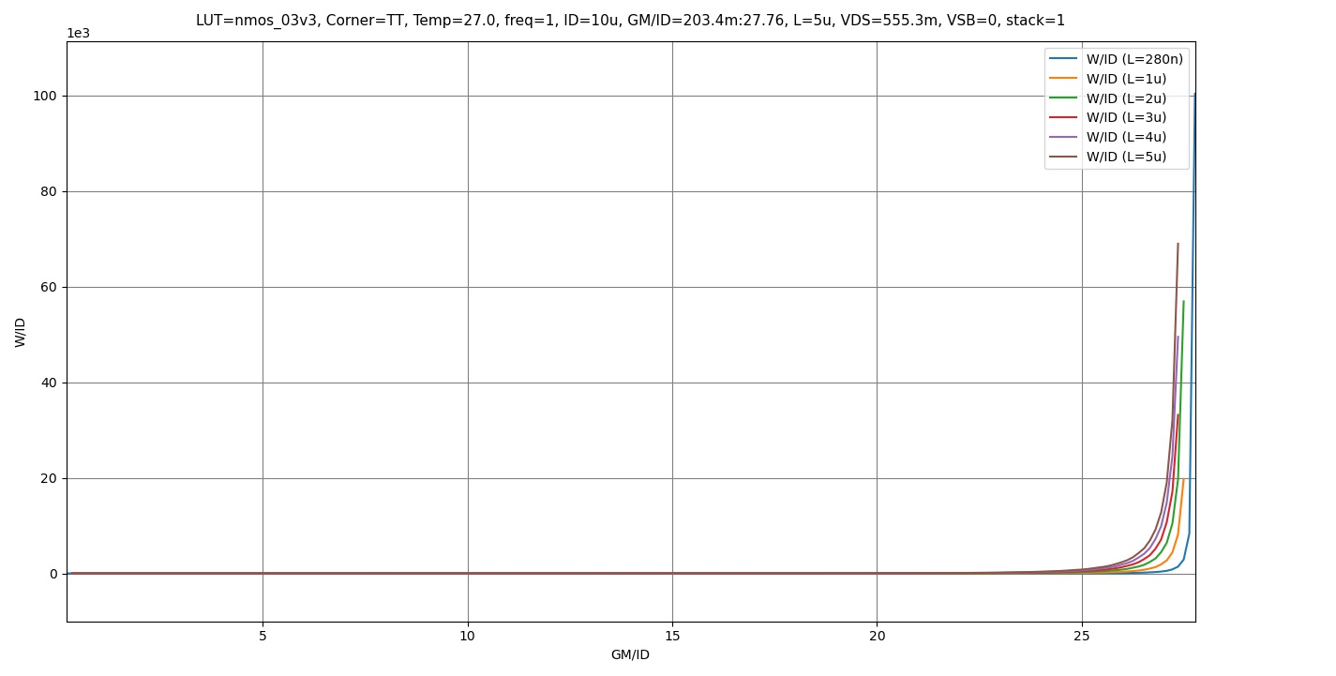

Figure 2 W/ID vs gm/ID

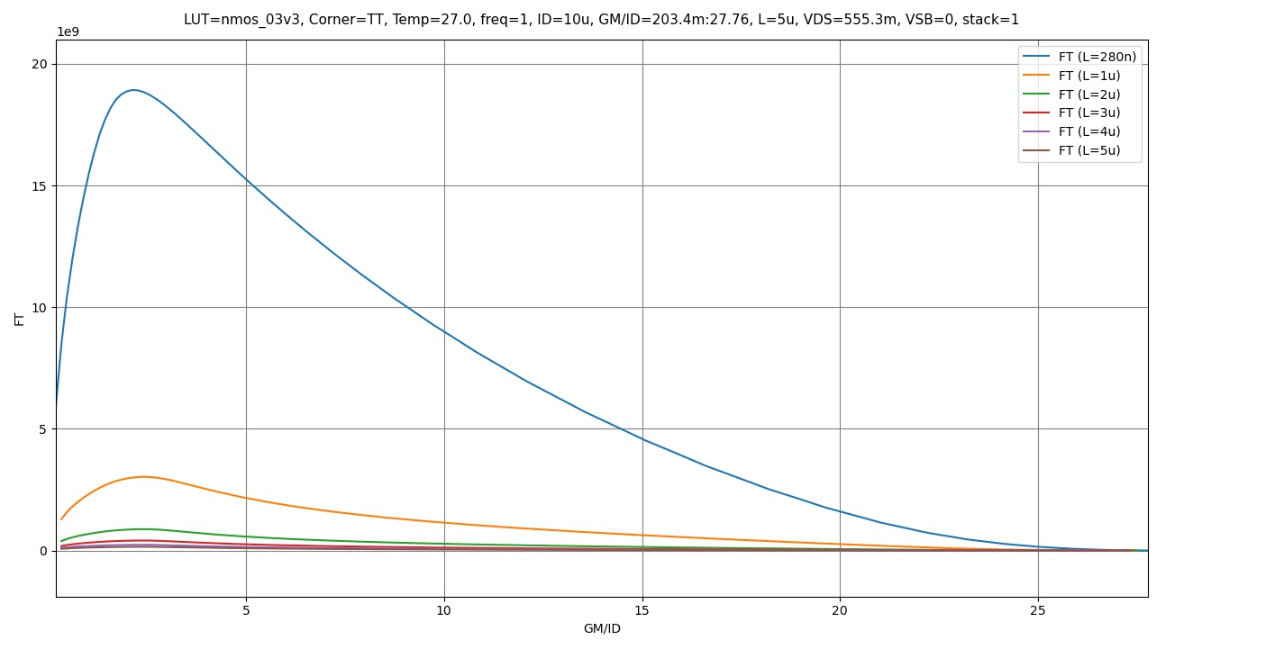Figure 3 fT vs gm/ID
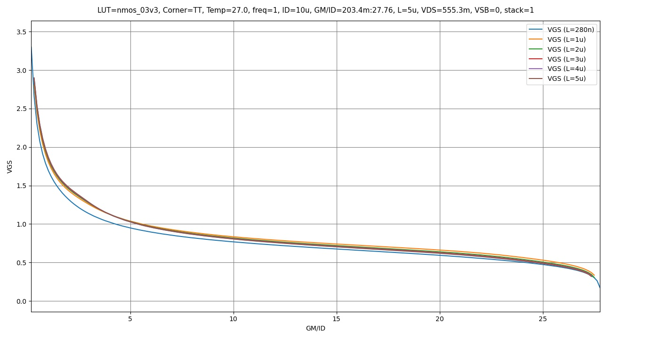
Figure 4 VGS vs gm/ID

PMOS Charts:
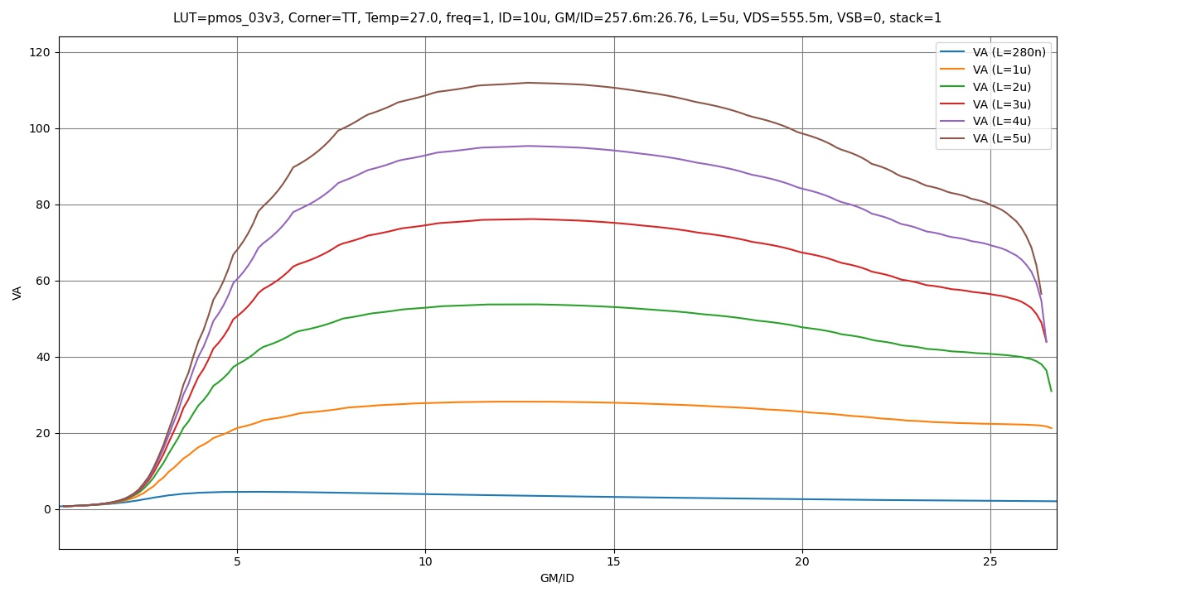
Figure 5 VA vs gm/ID

Figure 6 W/ID vs gm/ID

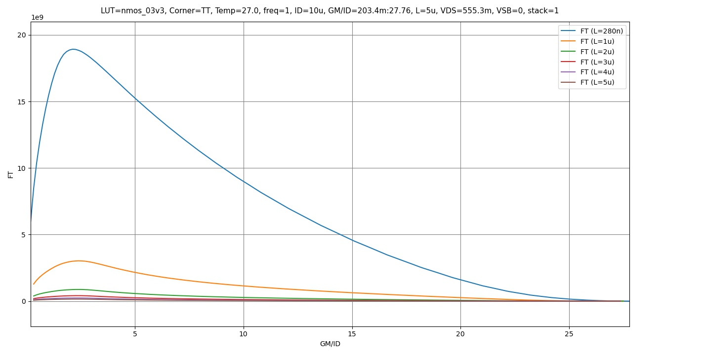
Figure 7 fT vs gm/ID

Figure 8 VGS vs gm/ID

Part 2: OTA Design
Required Specifications:
Technology | GF180MCU
Supply voltage | 2.5V
Closed loop gain | 2
Phase margin at the required ACL | >= 70o
CM input range – low | <= 0
CM input range – high | >= 1V
Differential output swing | 1.2Vpk-to-pk
Load | 500fF
DC Loop gain | 60dB
CL settling time for 1% error | 100ns

Design Observations:
Input Range Closer to the ground rail, calls for PMOS Input Stage
Required gain is huge.
Wide Output Swing

Thus, a Folded Cascode Amplifier with PMOS Input stage is the best topology for this spec.

We can take into consideration the loading effect seen by the feedback capacitor for the Closed Loop gain to make our analysis easier later on:

$$β=\frac{C_{F}}{C_{F}+C_{IN}}=\frac{1p}{1p+2p}=\frac{1}{3}$$
$$LG=60dB→1000=A_{OL}*β→A_{OL}=3000$$
We will use these values of gain for every pair of the design.

Input Transistors:
Using the spec for 1% error time settling:
$$e^{-\frac{T}{τ}}*100=1→τ=21.7ns$$
$$BW_{CL}=\frac{1}{2πτ}=7.33MHz≈7.5MHz \left(For easier Analysis\right)$$
Taking Loading Effect into consideration and Output capacitance as it is comparable to load capacitance:
$$GBW_{CL}=A_{CL}*BW_{CL}=15MHz=\frac{gm_{in}}{2π\left(C_{out}+C_{F}+C_{L}\right)}→gm_{in}≈150μS$$
Assume gm/id = 15 MI or WI
$$I_{D}=10μA$$
$$Assume L=500nm→Short L to reduce input capacitances$$
$$Assume V_{DS}=\frac{VDD}{3}≈0.8333$$
Put into ADT
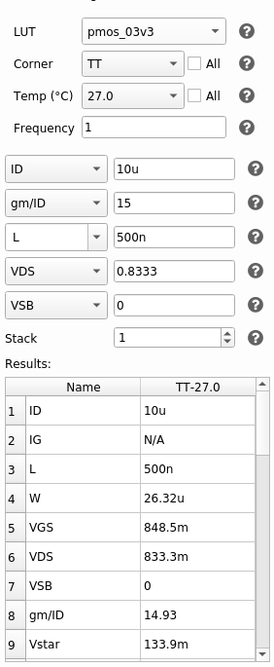
Figure 9 Snippet for ADT For Input Pair
$$L=500nm , W=26.5μm$$

PMOS Current Mirror Load:
Assume Large L: For lower mirroring error
$$L=1μm$$
Assume SI, MI: Lower gm thus Lower Noise
$$\frac{gm}{I_{D}}=10$$
$$I_{B}=2*I_{D}=10μA$$
$$V_{DS}=\frac{V_{DD}}{3}=0.8333$$
Into ADT:
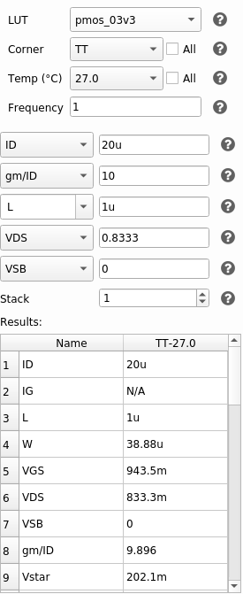
Figure 10 ADT Snippet for Current Mirror Load
$$L=1μm , W=38.88μm≈39μm$$

NMOS Current Mirror:
Same Assumptions as previously:

Assume Large L: For lower mirroring error
$$L=1μm$$
Assume SI, MI: Lower gm thus Lower Noise
$$\frac{gm}{I_{D}}=10$$
$$I_{B}=10μ+4μ=14μA→Explained in the next section$$
$$V_{DS}=\frac{V_{DD}}{3}=0.8333$$

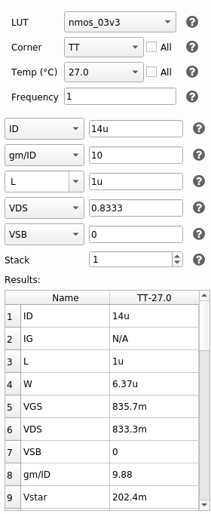
Figure 11 ADT Snippet for NMOS Current Mirror

$$L=1μm , W=6.37μm$$

Current Mirror:
Sizing the Top current mirror transistor with 1 fifth the Width calculated in the first part to run 2/5 of the current through the CG branch this paper showed that a splitting ratio higher than 1 yields better results, thus I’m using a splitting ratio of 2.5:
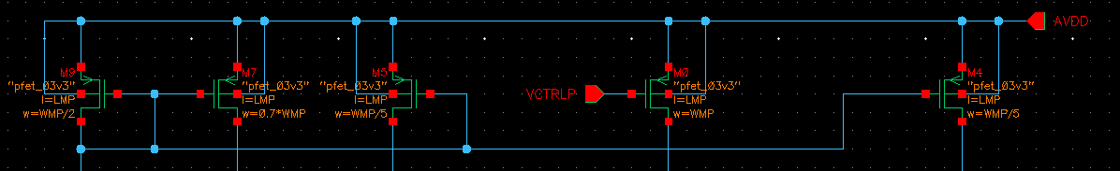
Figure 12 Tail Current Mirror
Paper Link: https://www.researchgate.net/publication/339758769_Optimum_Split_Ratio_for_Folded_Cascode_OTA_Bias_Current_A_Qualitative_and_Quantitative_Study
Cascode Devices:
Assuming Moderate Length:
$$L=500nm$$
And WI inversion for higher gain:
$$\frac{gm}{ID}=15$$
$$V_{DS}=\frac{VDD-\frac{VDD}{3}}{3}=0.5556V$$
$$(as third the voltage is already taking by the nmos Current Source)$$
$$I_{D}=4μA$$
Into ADT for NMOS Device:
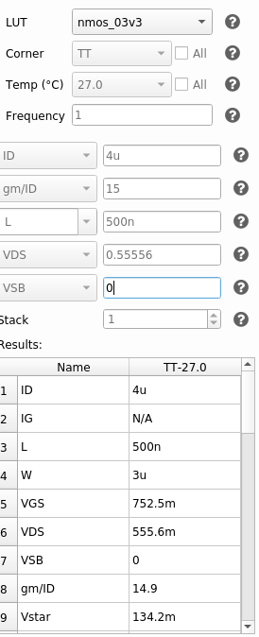
Figure 13 ADT Snippet for NMOS Cascode Device
$$L=500mm , W=3μm$$

Into ADT for PMOS Device:
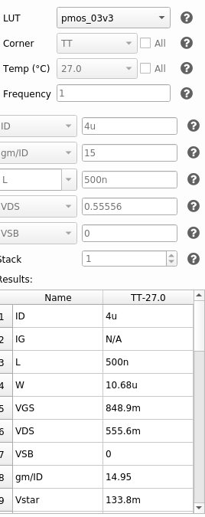
Figure 14 ADT Snippet for PMOS Cascode Device
$$L=500mm , W=10.68μm$$
Bias Voltages:
$$V_{CASCN}=V_{GScascN}+V_{MN}^{*}=0.9525V$$
$$V_{CASCP}=V_{DD}-V_{GScascP}-V_{MP}^{*}=1.45V$$
Choosing slighter higher and lower values to ensure transistor operate in saturation:
$$V_{CASCN}=1V$$
$$V_{CASCP}=1.3V$$

Initial Design Point:
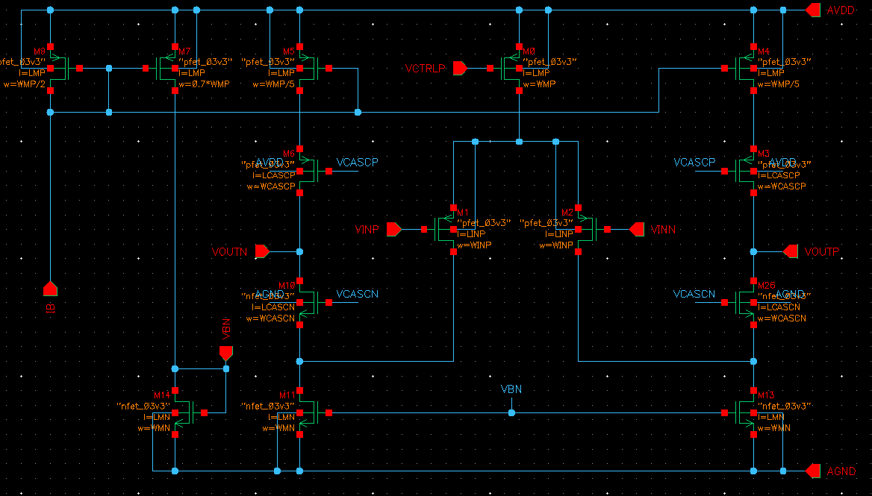
Figure 15 Final Sizing for First Iteration and Topology
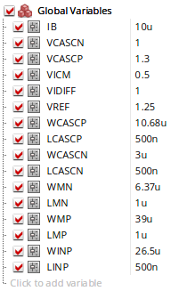
Figure 16 Initial Design Parameters
To Test the initial Design point, I set up a simple testbench using the behavioral CMFB Network and tested DC Point and Gain Values to fine tune them.
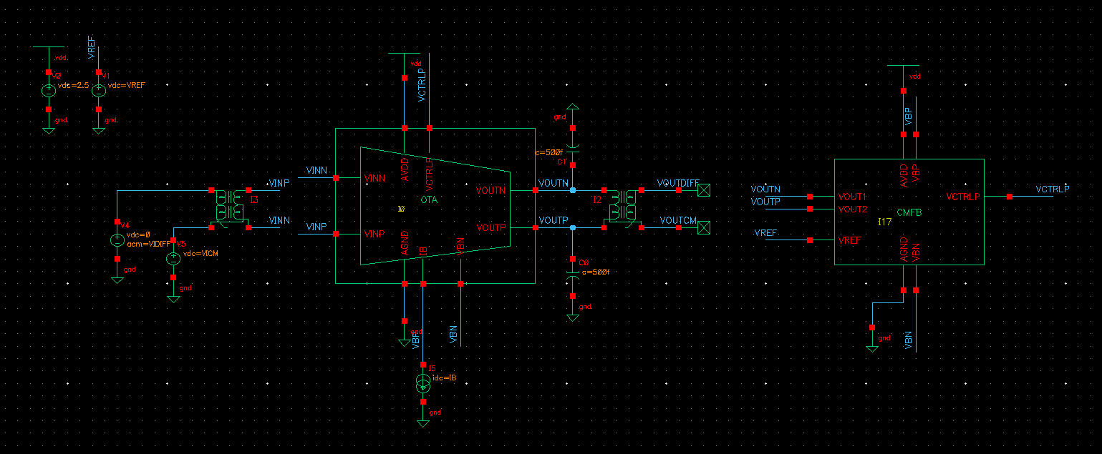
Figure 17 OL Testbench Schematic
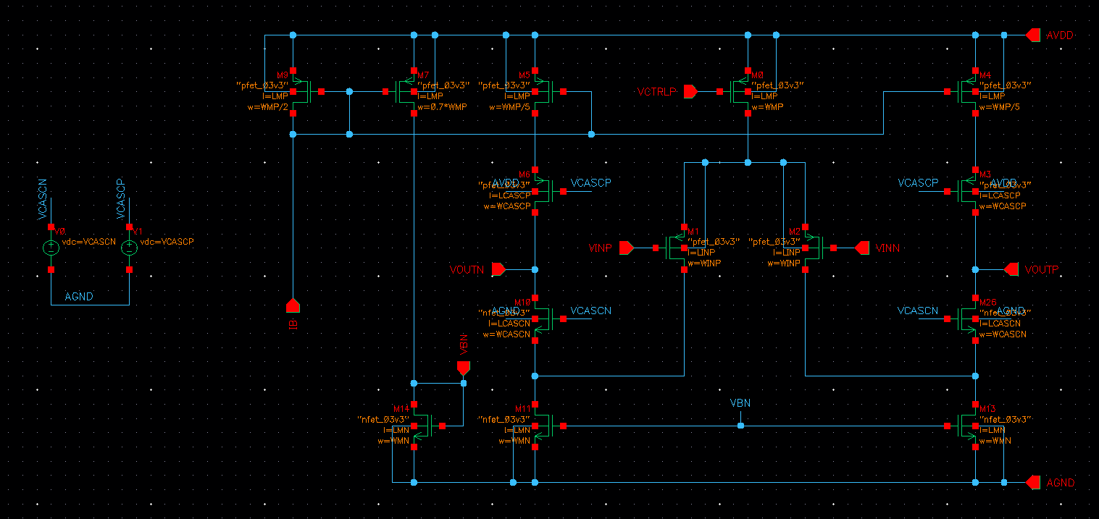
Figure 18 OTA Schematic
I simulated the Bias voltages on the side at the beginning using ideal voltage sources for fine tuning, I will be designing a bias circuit later.
Biasing Circuit:
Using the calculated dimensions, I acquired acceptable results right away, so I moved on directly to the biasing circuit.

I wanted to design the circuit how it would be designed in real life using a practical approach, so I searched the web for biasing circuit for the folded cascode OTA till I found one being discussed in the following forum discussion:
folded cascode biasing | Forum for Electronics

Biasing Circuit with initial Sizing:
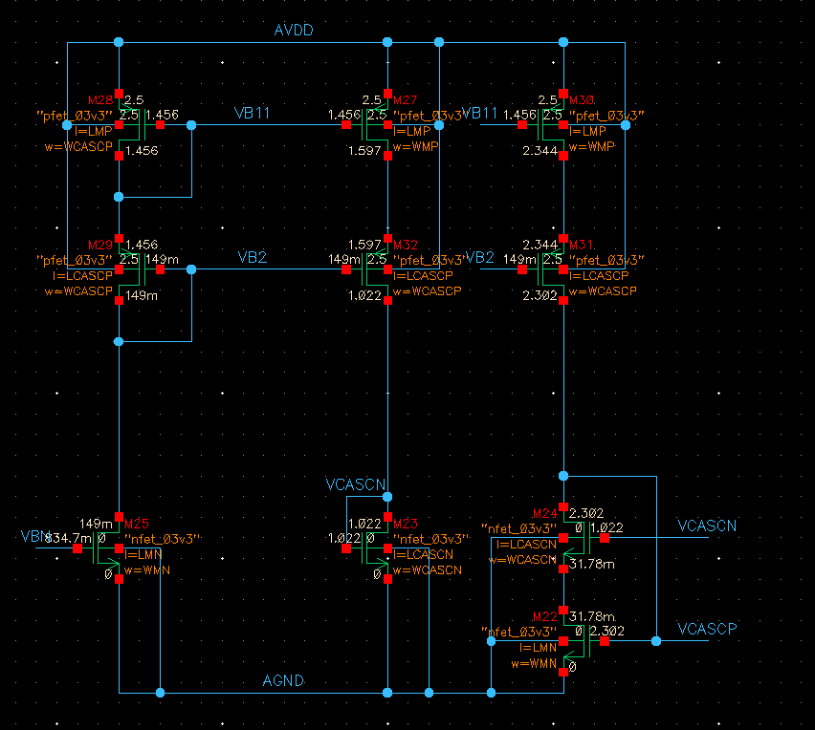
Figure 19 Folded Cascode Biasing Circuit

I made some adjustments to the circuit to better suit my needs:
I used an NMOS transistor connected to the NMOS Tail current mirror from the OTA to drive this circuit
I used the same sizing as the Cascode devices to be biased and the mirror devices they are following
The Cascode configuration in this circuit seems to be for better stability or higher accuracy of the circuit

For sizing I had no specific plan to go about it, so I essentially put the same sizing as the cascode, and mirror devices required to be biased and started adjusting the widths to control VGS and reach the required voltages calculated in the different part
I noticed the three NMOS transistors in the bottom right of the circuit have the higher effect, so I focused my fine tuning on them.

Final Sizing of the Bias Circuit:
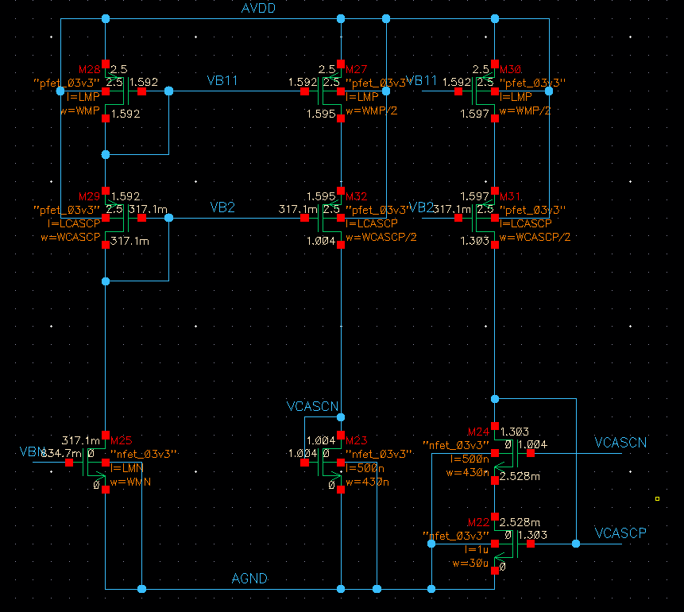
Figure 20 Final Biasing Circuit after fine tuning
I quickly realized I need more current to reach the required voltage so I adjusted the current mirror according to then focused the rest of the tine tuning on the bottom 3 transistor adjust their width accordingly to control their VGS and thus the values for VCASCN and VCASCP till they reach their values achieved in the previous section.

PART 3: Open-Loop OTA Simulation (Behavioral CMFB)
Having finished designing and fine tuning the circuit on cadence virtuoso I decided to continue my simulations on Xschem and ngspice for the better control and automation they give me over the circuit.
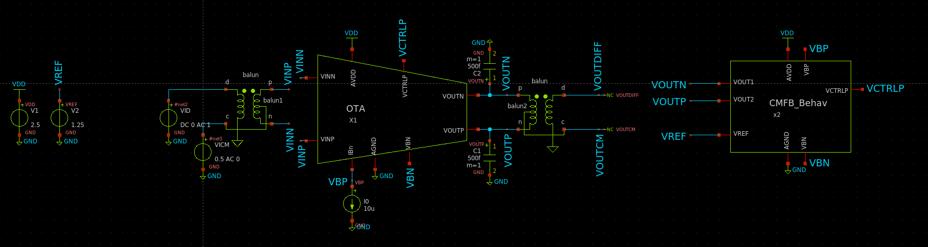
Figure 21 XSchem Testbench
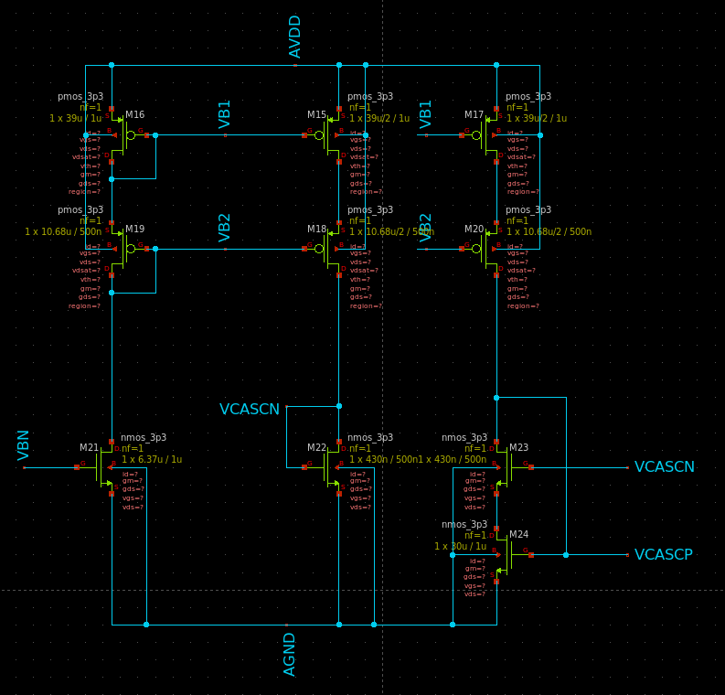
Figure 22 Biasing Circuit in Xschem

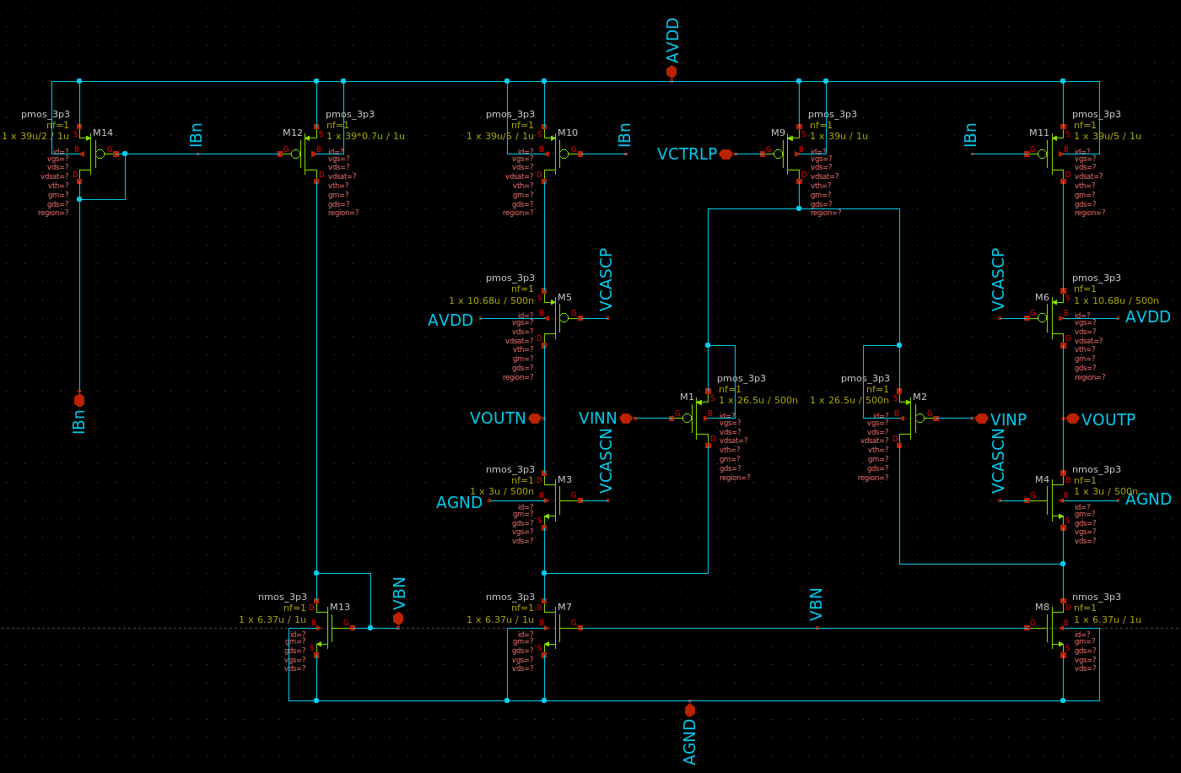
Figure 23 OTA in Xschem

OP Analysis:
Using VICM = 0.5V in the middle of CMIR
Using VREF at 1.25 in the middle of VDD for maximum output swing

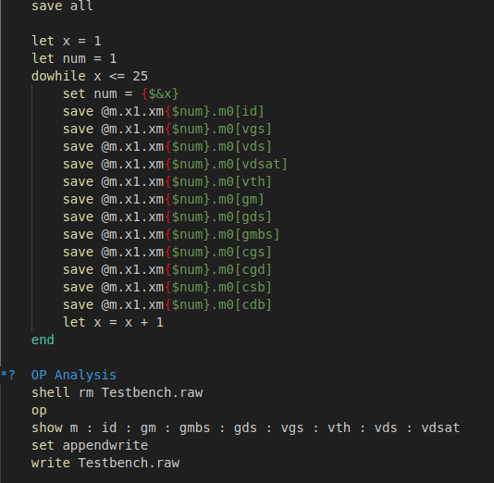
Figure 24 OP Analysis Code
To Showcase region in Xschem I used the TCL code provided by Amir Sameh on Canvas to show the region on the transistor symbol:
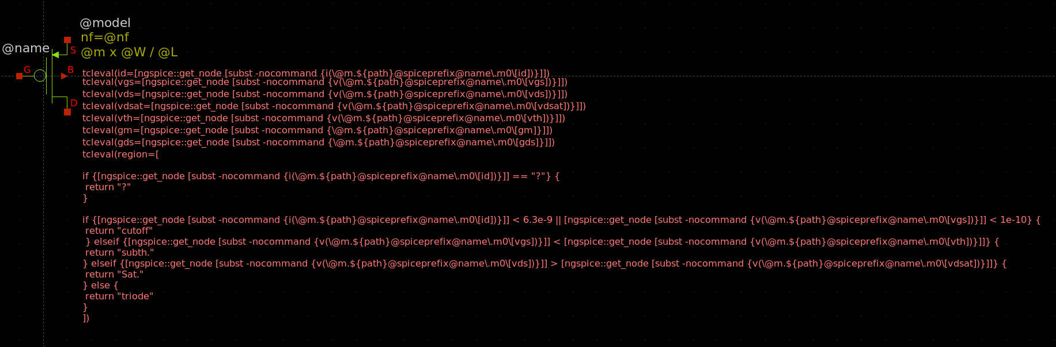
Figure 25 Region Symbol with region code
Results:
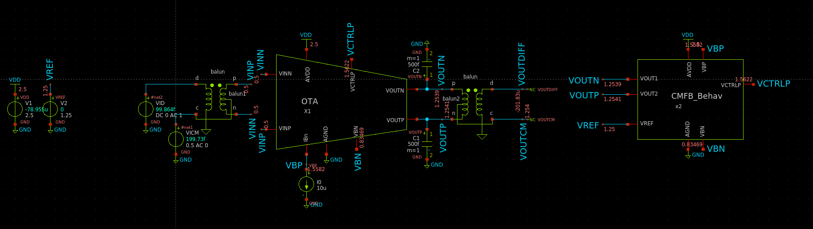
Figure 26 DC Voltages Annotated on Testbench Schematic
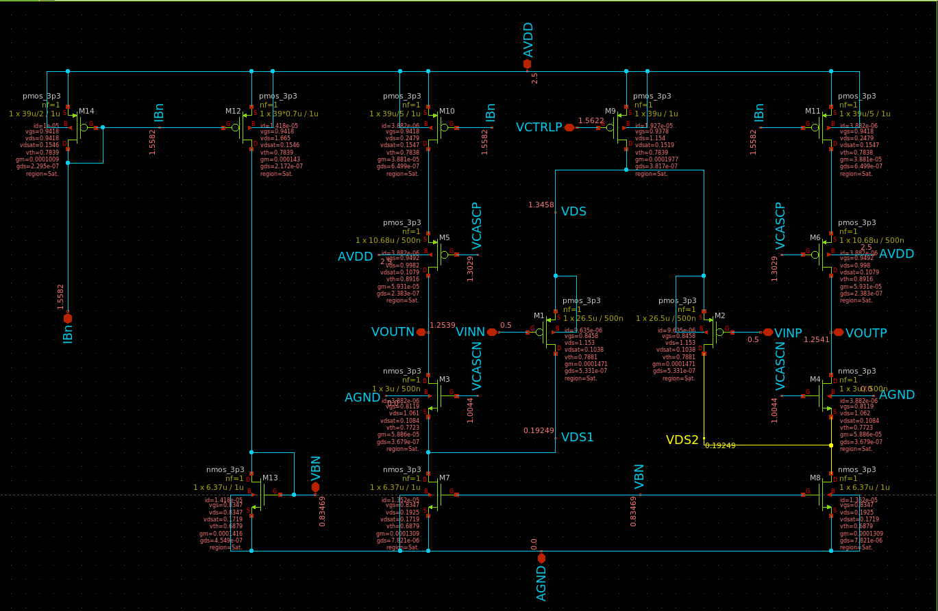
Figure 27 DC Voltages Annotated on OTA Schematic

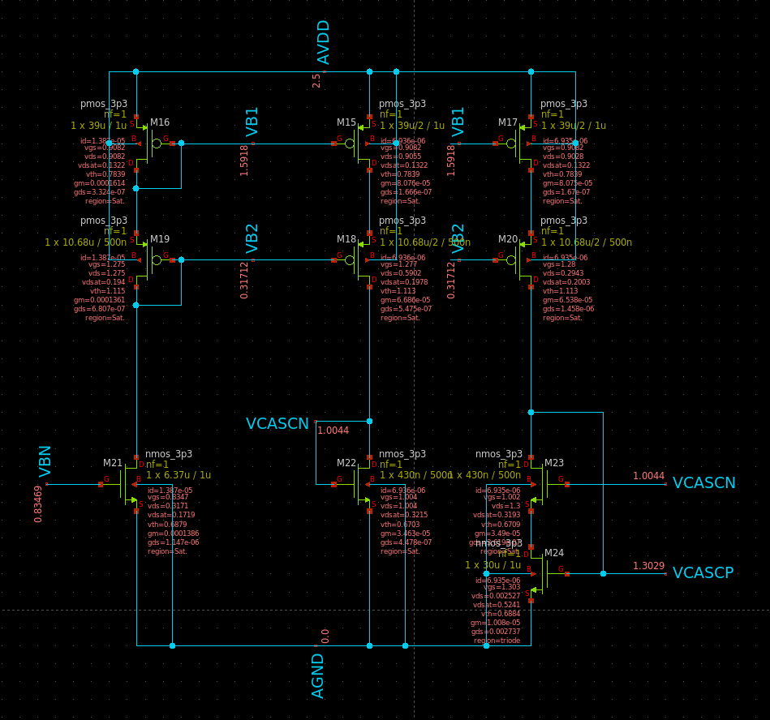
Figure 28 DC Voltages Annotated on Biasing Circuit

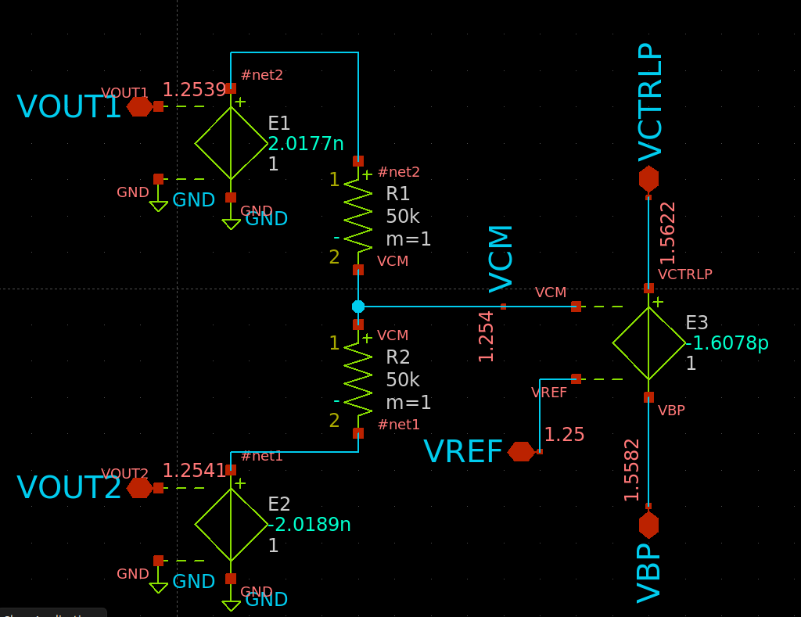
Figure 29 Ideal CMFB Voltages

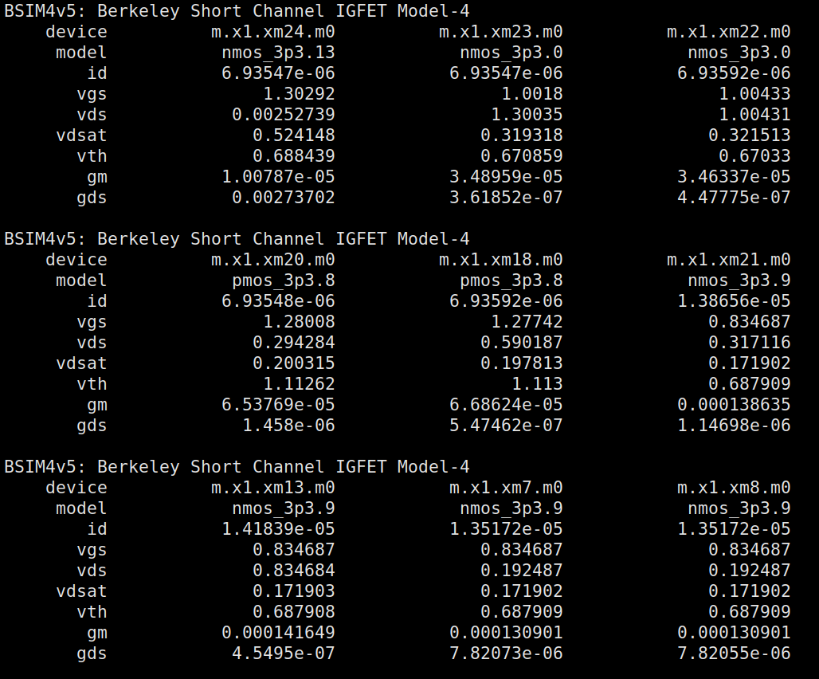
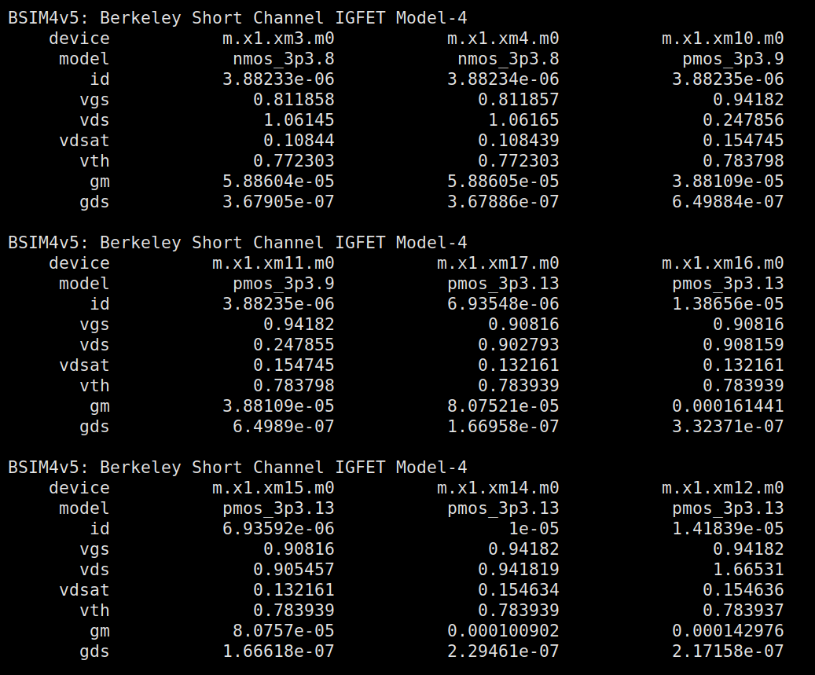
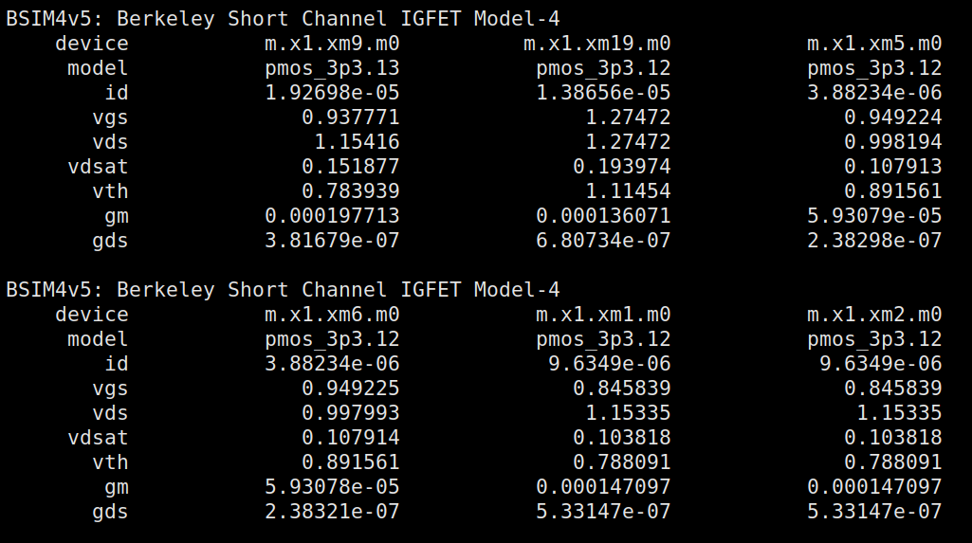
Figure 30 DC Op Point of all transistors
• What is the CM level at the OTA output?
$$V_{CMOUT}≈1.25=V_{REF}$$
• What are the differential input and output voltages of the error amplifier? What is the relation between them?
$$VIN_{diff}=1.254-1.25=0.004., VOUT_{diff}=1.5622-1.5582=0.004$$
The relationship between them is unity which is equal to the gain of error amplifier.

Differential Small Signal:
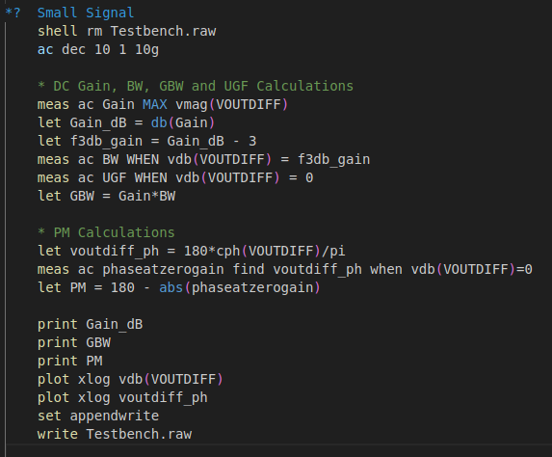
Figure 31 Diff SS Simulation Script
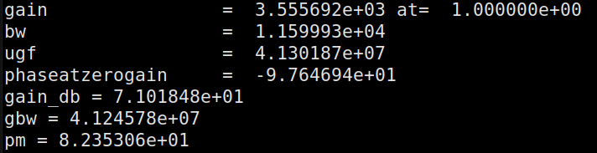
Figure 32 Simulation Results

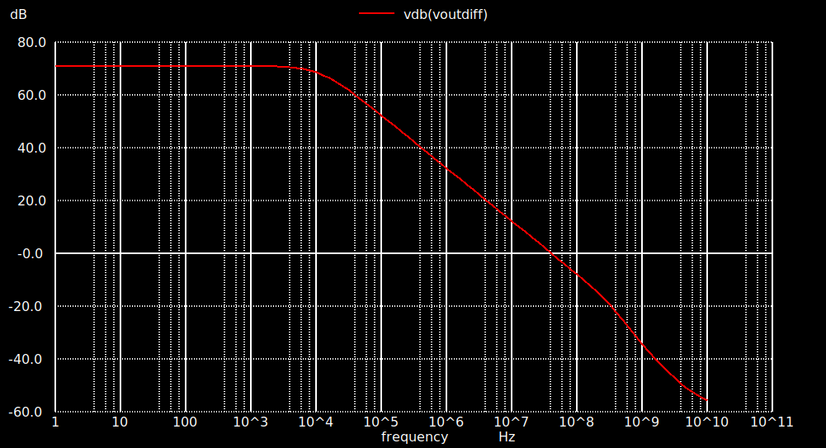
Figure 33 DC AOL Gain mag in dB
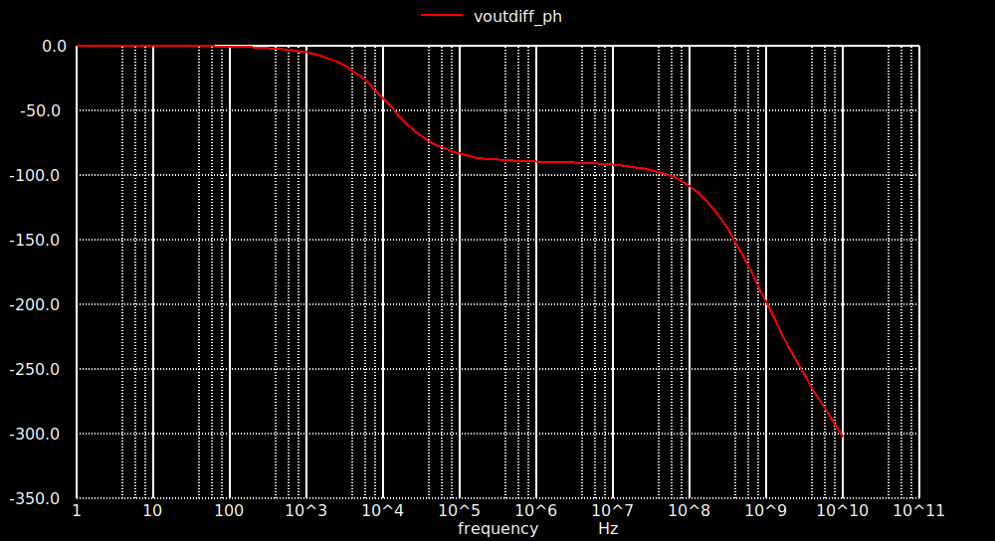
Figure 34 DC AOL Gain Phase vs Frequency
Hand Analysis:
$$R_{OUT}=\left[gm_{cascn}ro_{cascn}\left(r_{mn}//ro_{inp}\right)\right]//gm_{cascp}ro_{cascp}ro_{mp}≈18.3MΩ$$
$$A_{OL}=GmR_{OUT}=147μ*18.3M=2.675K$$
$$BW_{OL}=\frac{1}{2πR_{OUT}C_{OUT}}≈17.5KHz$$
$$GBW_{OL}=UGF=A_{OL}*BW_{OL}=46.812MHz$$
 | Simulation | Hand Analysis
Open Loop gain | 3555.7 | 2675
BW | 11.6KHz | 17.5KHz
GBW | 41.2MHz | 46.812MHz
UGF | 41.3MHz | 46.812MHz

There is a difference between the simulation and analytical results possibly due to errors in calculating gds and due to neglecting the body effect of the cascode devices in the simulation resulting in a lower ROUT than expected thus a lower gain, but the results are still comparable to what’s expected.
PART 4: Open-Loop OTA Simulation (Actual CMFB)
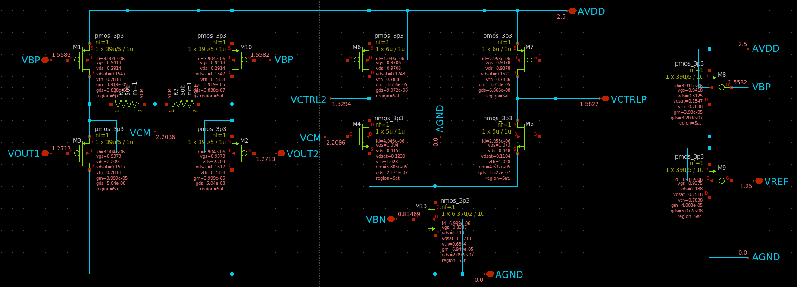
Figure 35 Real CMFB Network
Sizing Procedure:
Common Mode Sensing is done by a common drain, it is connected to the same mirror as the PMOS Mirror in the OTA and has the same sizing as them to run the same current.
For Simplicity I gave them all the same sizing as the Mirrors driving the current in the CG Branch.
Additionally I fed Vref through the same CD to account for the Voltage shift caused by |VGSP|

This Leaves me with the differential amplifier pairs and their current mirror source:
The current mirror source is given the same sizing as the NMOS Sink Current sources in the OTA but with half the W/L for half the current budget of the OTA (7uA)

Error Amplifier:
All we have for the amplifier is that is requires a small gain nothing huge, so we’ll assume unity gain or a bit higher than it
$$let A_{v}=\frac{gm_{n}}{gm_{p}}≈1.5$$
$$Assume {\left(\frac{gm}{I_{D}}\right)}_{in}=15 (MI) , L=1μm$$
$$I_{D}=3.5μA$$
Into ADT with appropriate VDS:
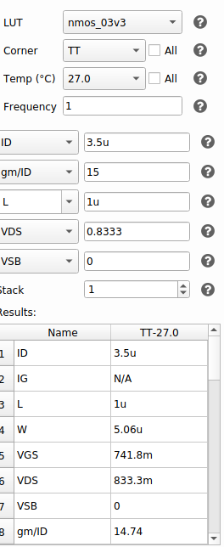
$$L=1μm , W=5μm , gm_{n}=50μS$$

Accordingly, I can acquire the dimensions for the PMOS Load:

Using previous assumptions
$$gm_{p}=\frac{gm_{n}}{1.5}=33.33μS$$
$$Assum L=1μm$$
$$I_{D}=3.5μA$$
Into ADT with appropriate VDS:

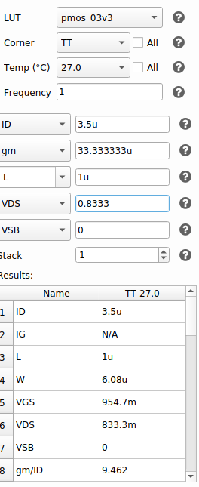
Figure 36 CMFB PMOS Load Sizing
$$L=1μm , W=6μm$$
After a little bit of fine tuning, I increased W just slightly to better match Vref
$$L=1μm , W=7μm$$
Calculating new Output Swing:
$$minimum Output Swing=V_{CASCN}^{*}+V_{MN}^{*}≈0.3333$$
$$maximum Output Swing=V_{DD}-V_{GSP}-V_{P}^{*}=2.5-0.9375-0.2=1.3625$$

$$Middle of Output Swing={V_{REF}}_{new}=0.847915≈0.85V$$
Using these values for the output swing we can calculate values of R
$$R_{1}+R_{2}=\frac{Vout_{MAX}-Vout_{MIN }}{I_{D}}=250KΩ$$
$$R=125KΩ$$
Note: I added the correct caps towards the end of the Lab, the results didn’t change much except in specific parameters at the end so as to save time and not repeat my analysis I kept all screenshots as is and only changed what changes with the current value of R.

Simulation:
I’ll reuse the same codes as the previous part.

OP Analysis:
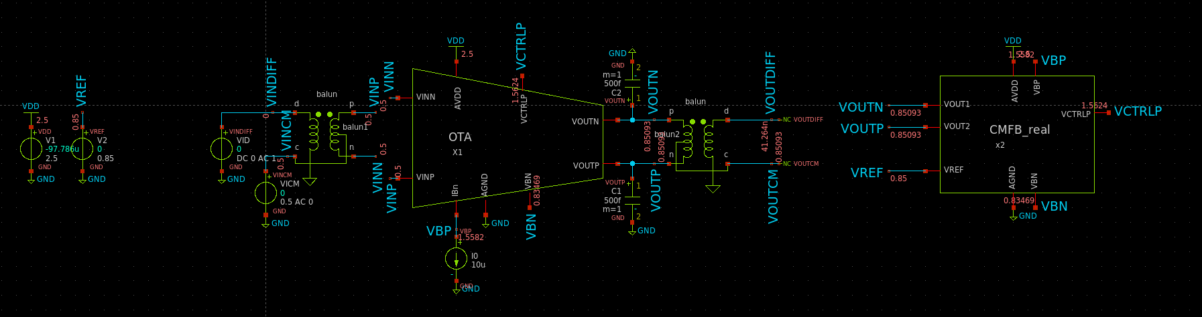
Figure 37 Testbench Voltages Annotated
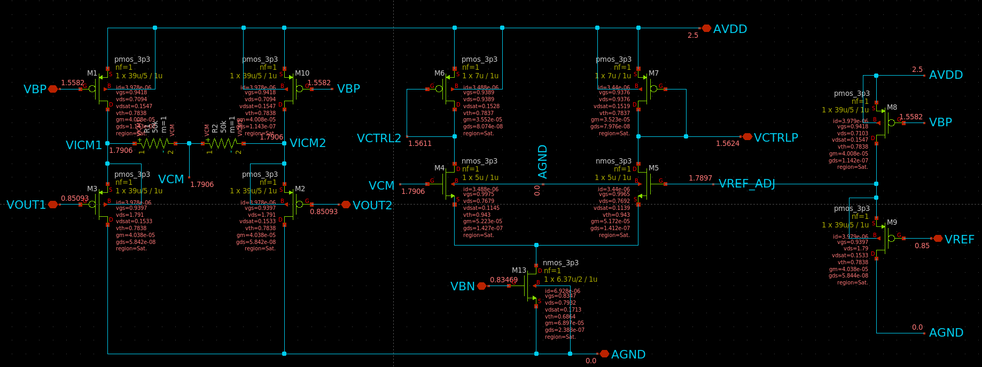
Figure 38 CMFB Voltages Annotated
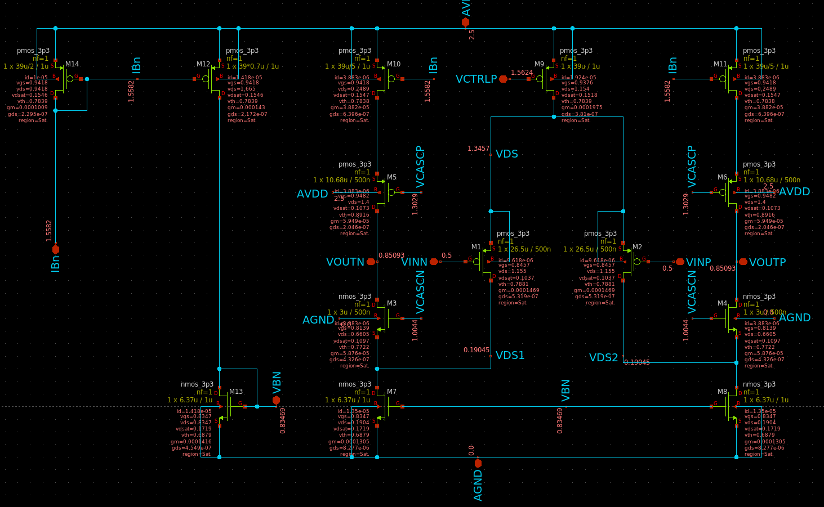
Figure 39 Latvia is actually Good at Winter
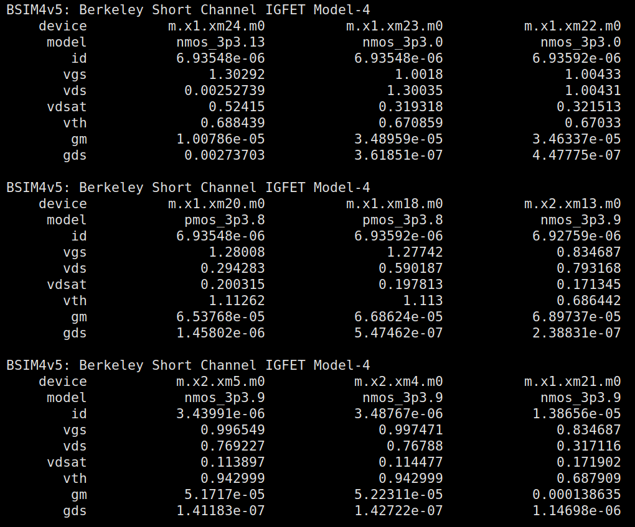

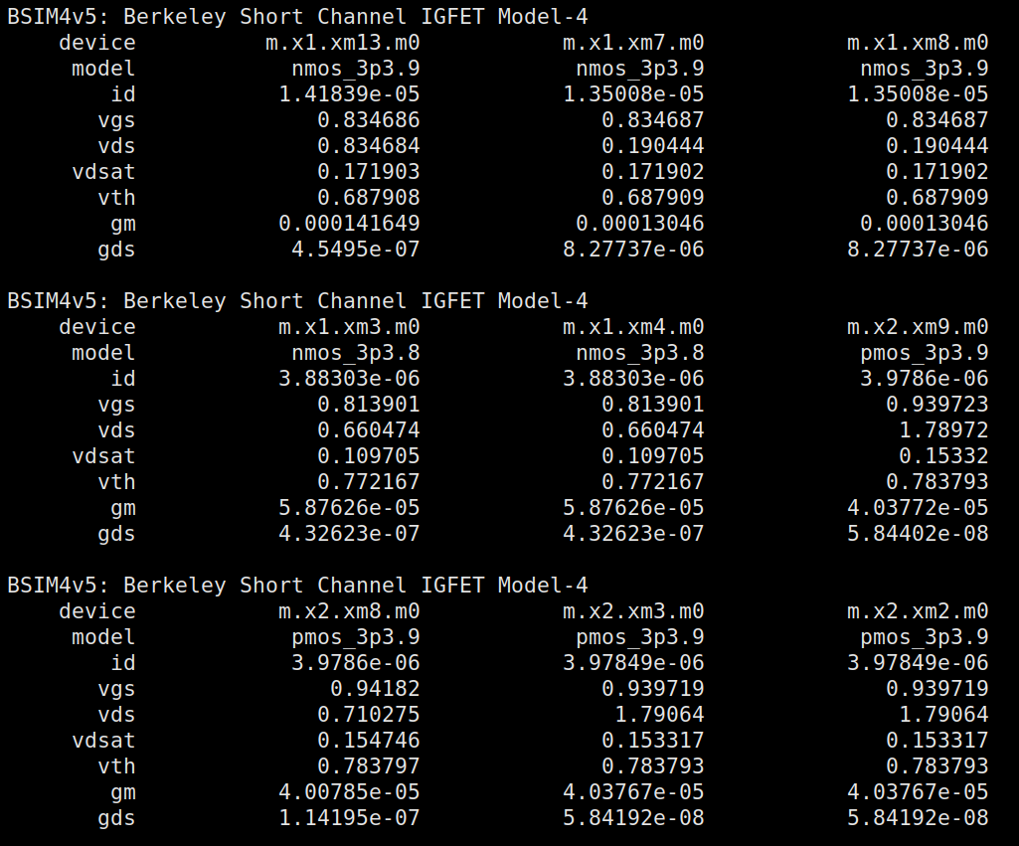

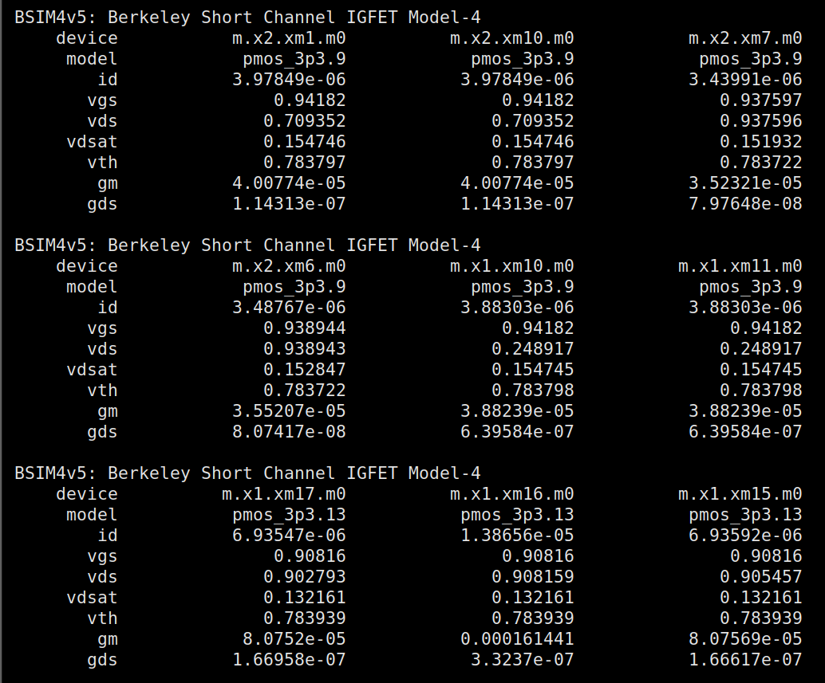Figure 40 All Transistor OP Point

• What is the CM level at the OTA output? Why?
Voltage at the Output is equal to 0.85V, which is equal to Vref, because it is being set to VREF by the CMFB Loop

• What are the differential input and output voltages of the error amplifier? What is the relation between them?
$$VDIFF_{IN}=1.7906-1.7897=0.0009$$
$$VDIFF_{OUT}=1.5624-1.5611=0.0013$$
$$\frac{VDIFF_{OUT}}{VDIFF_{IN}}=1.4444$$
The relationship between them is almost equal to the Small Signal gain the amplifier was designed to sustain while sizing it in the previous part.

Differential Small Signal:
Using the same setting as last time as well as same code

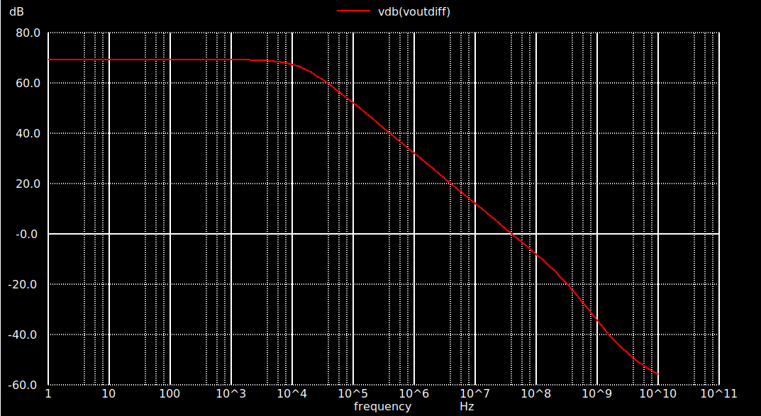
Figure 41 Diff Gain in dB
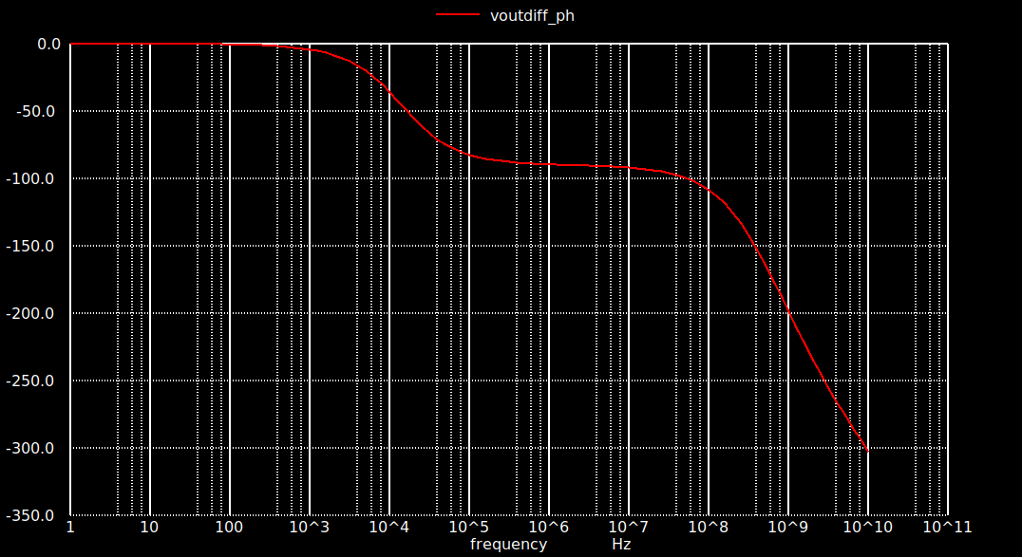
Figure 42 Diff Gain phase vs Freq

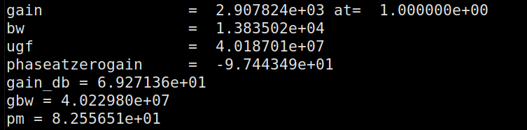
Figure 43 Circuit Parameters
 | Behavioral | Real
Open Loop gain | 3555.7 | 2907.8
BW | 11.6KHz | 13.83KHz
GBW | 41.2MHz | 40.2298MHz
UGF | 41.3MHz | 40.187MHz
PM | 82.3 | 82.5565

There is a slight decrease in gain from the Behavioral to the real and a slight increase in BW, meaning the Output resistance possibly decreased due to changing the output cm voltage

I fixed this by increasing the bias voltages a little bit by increasing the current running through the Bias Circuit.
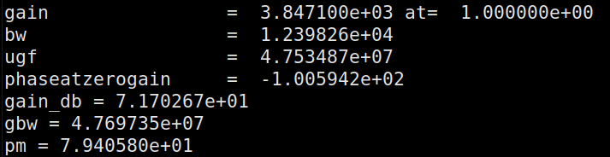
Figure 44 After Tweaking

PART 5: Closed Loop Simulation (AC and STB Analysis)
OP Analysis:
Done using the same code as before but only adding an extra save loop to save the component parameters of the CMFB network:
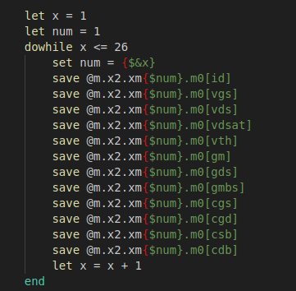
Figure 45 Extra Save dowhile loop for CMFB
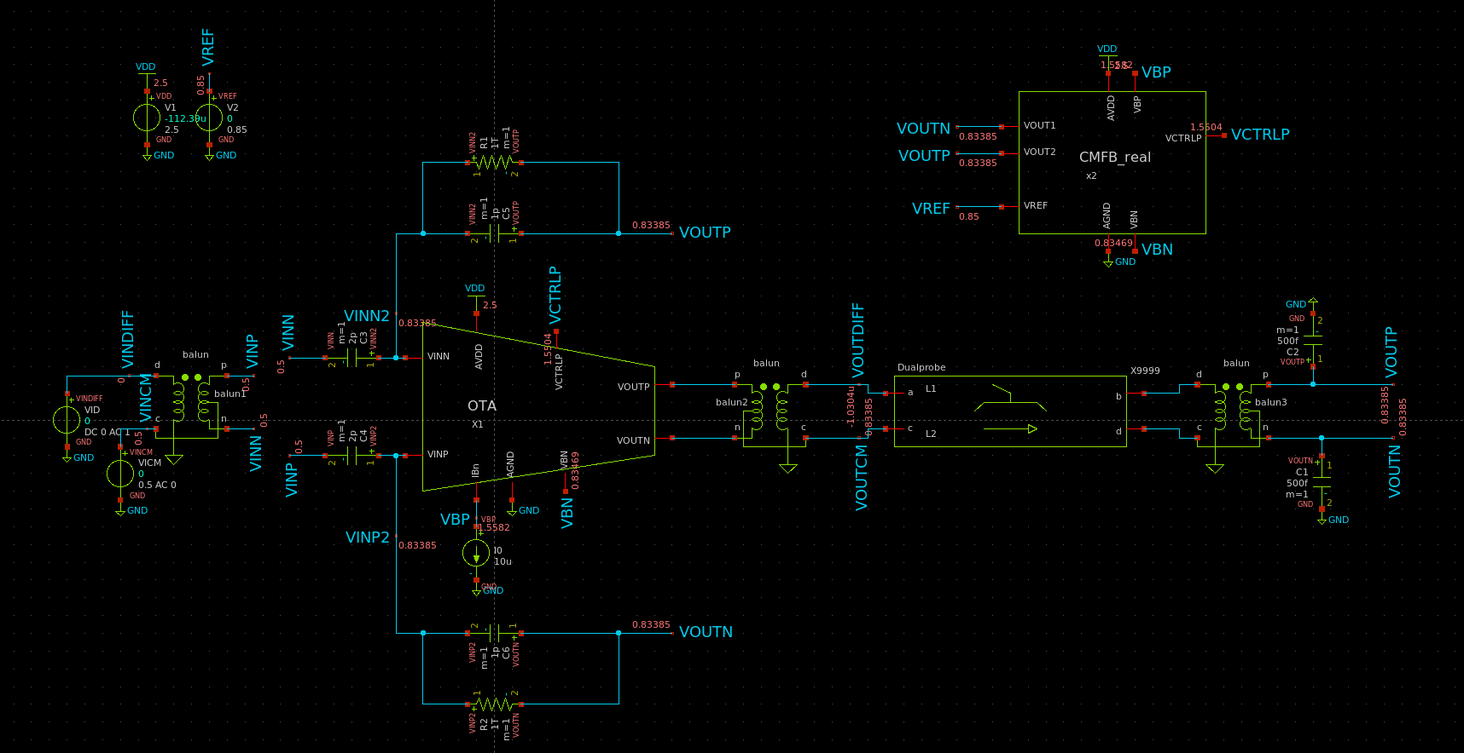
Figure 46 DC Voltages of Testbench Annotated

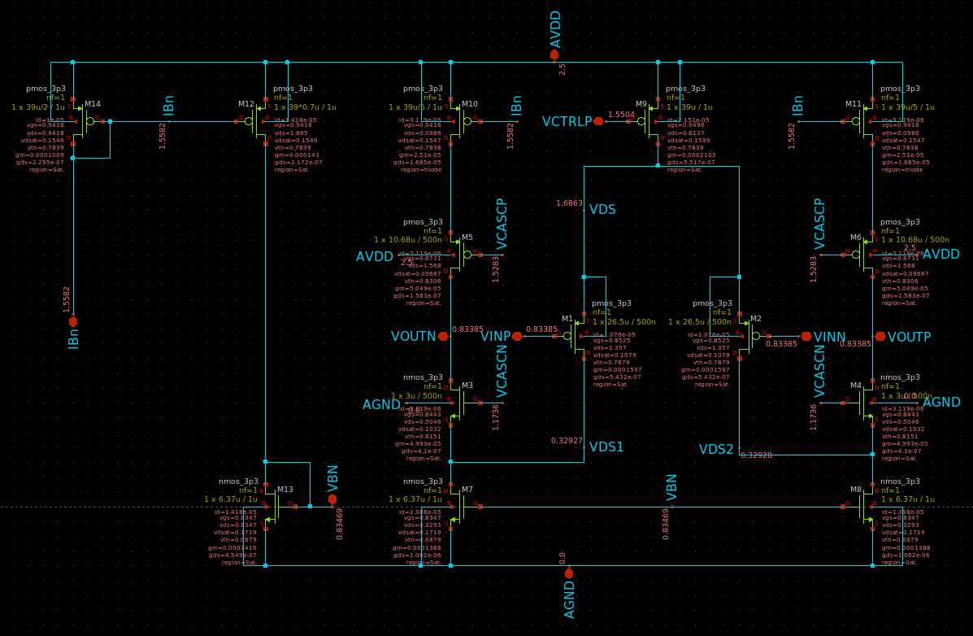
Figure 47 OP Point and DC Voltages of OTA
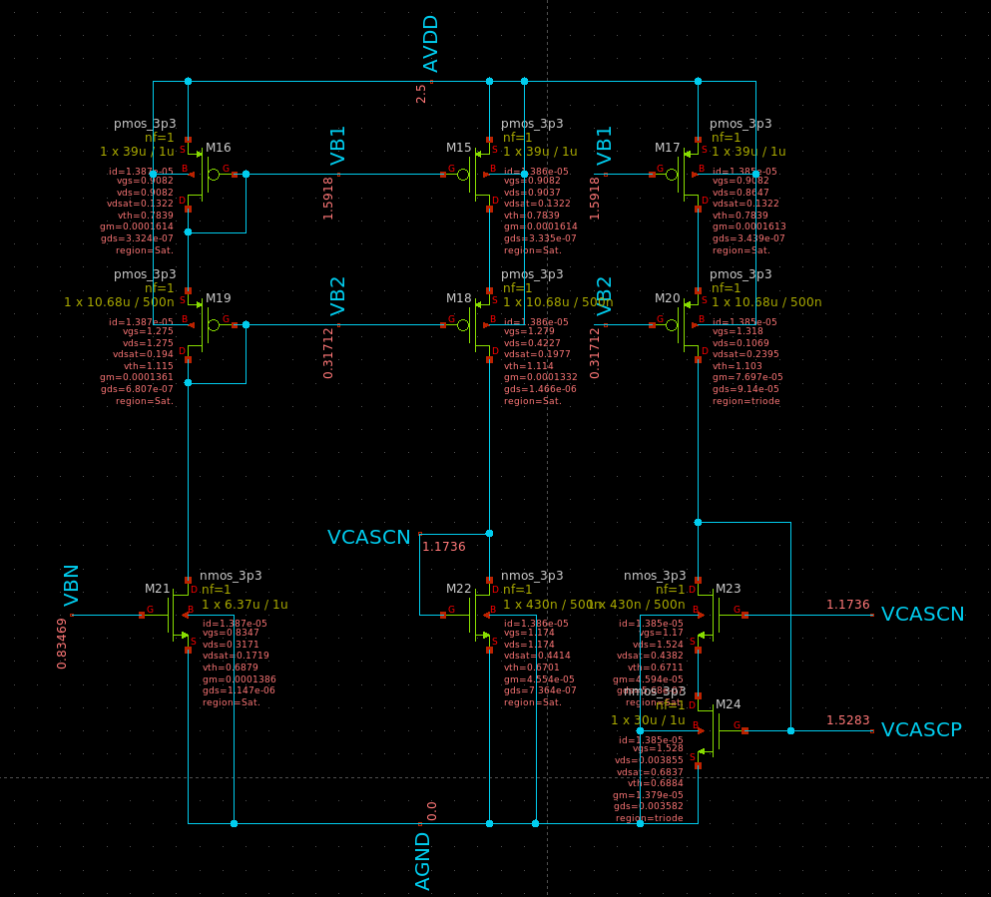
Figure 48 OP Point and DC Voltages of Bias Circuit
As seen here the current is higher than before in the bias circuit as I increased it by increasing the mirror ratio of the upper transistors to increase the bias voltages and increase the Open Loop gain of the OTA

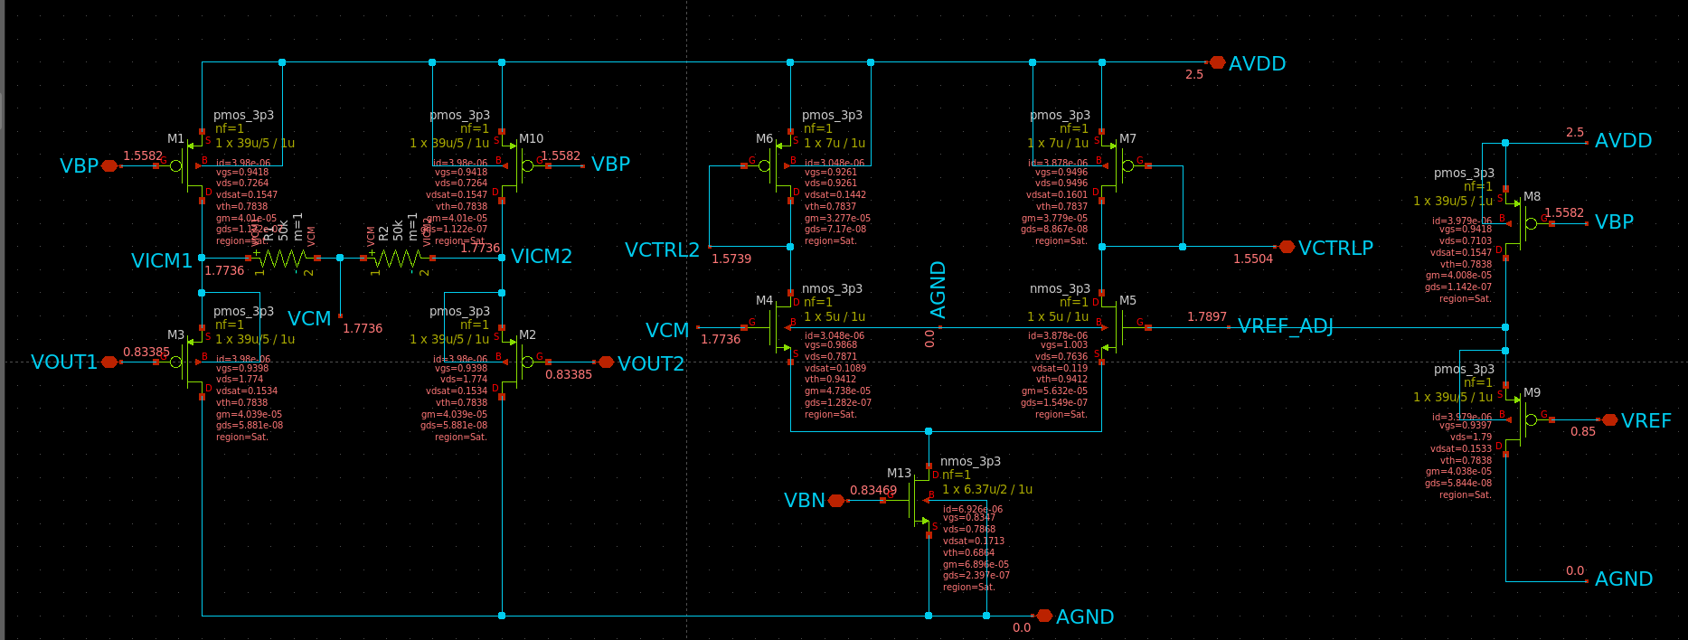
Figure 49 CMFB OP Point annotated and DC Voltages as well
• What is the CM level at the OTA output? Why?
It is equal to 0.83V almost equal to 0.85V the Reference voltage which is it being set to by the CMFB.

• What is the CM level at the OTA input? Why?
It is also equal to 0.83V as it is being set to the same voltage as the output by feedback

Differential Closed-Loop Response:
Again, using the same code as the previous parts for AC analysis and measures for the circuit parameters requested.
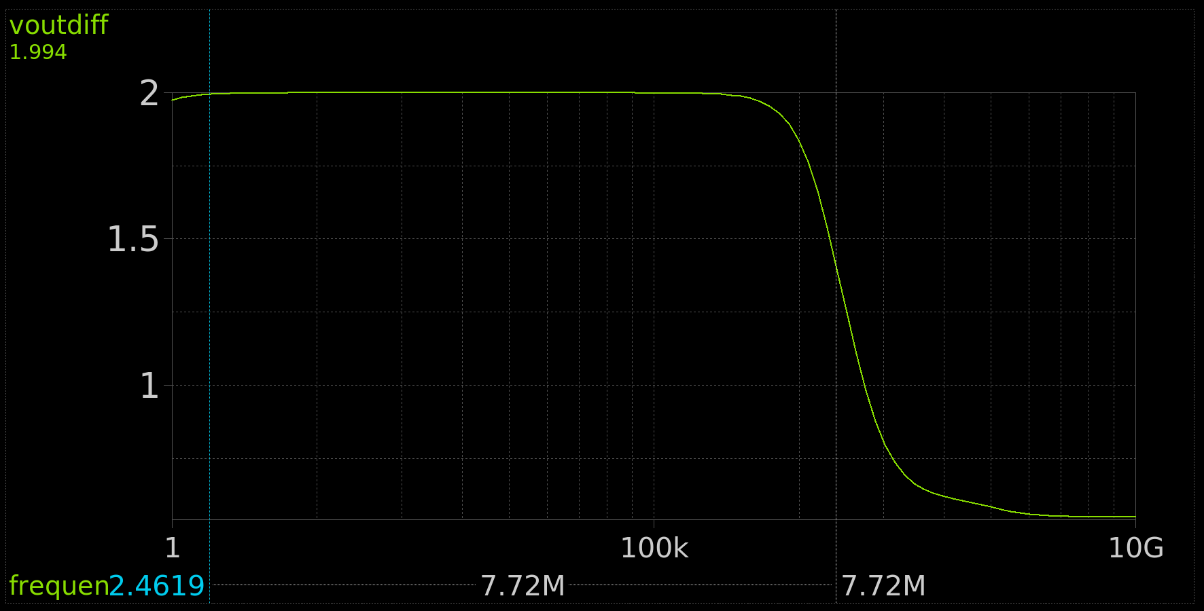
Figure 50 VOUTIFF vs Freq, CL Gain and CL BW Annotated
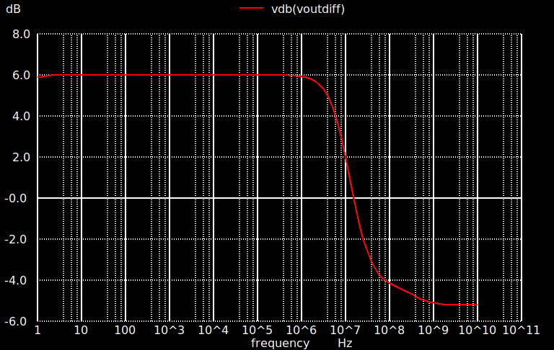
Figure 51 VOUTDIF in dB vs Freq

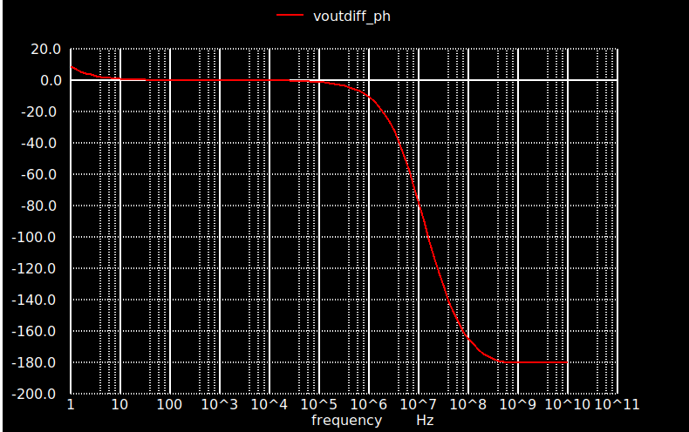
Figure 52 VOUTDIFF Phase vs Freq
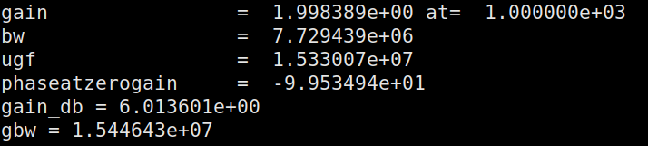
Figure 53 Circuit Parameters Measured in Simulation
 | Simulation
DC Gain | 1.9983
BW CL | 7.7294MHz
GBW CL | 15.4464MHz

STB Analysis:
For STB Analysis I used the DualProbe provided by Amir Sameh on Canvas with its code in it
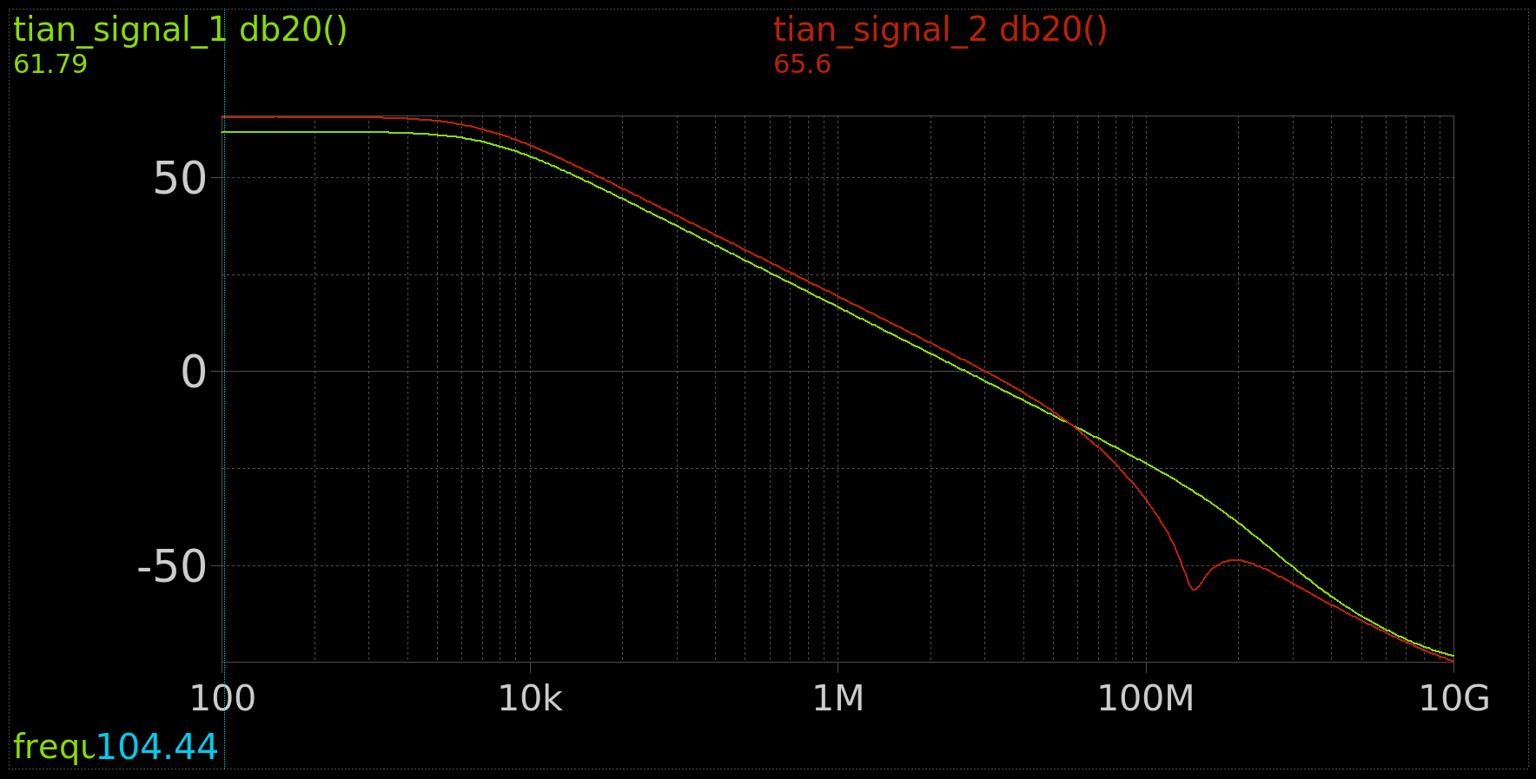
Figure 54 Loop Gain for CM and Diff Feedbacks
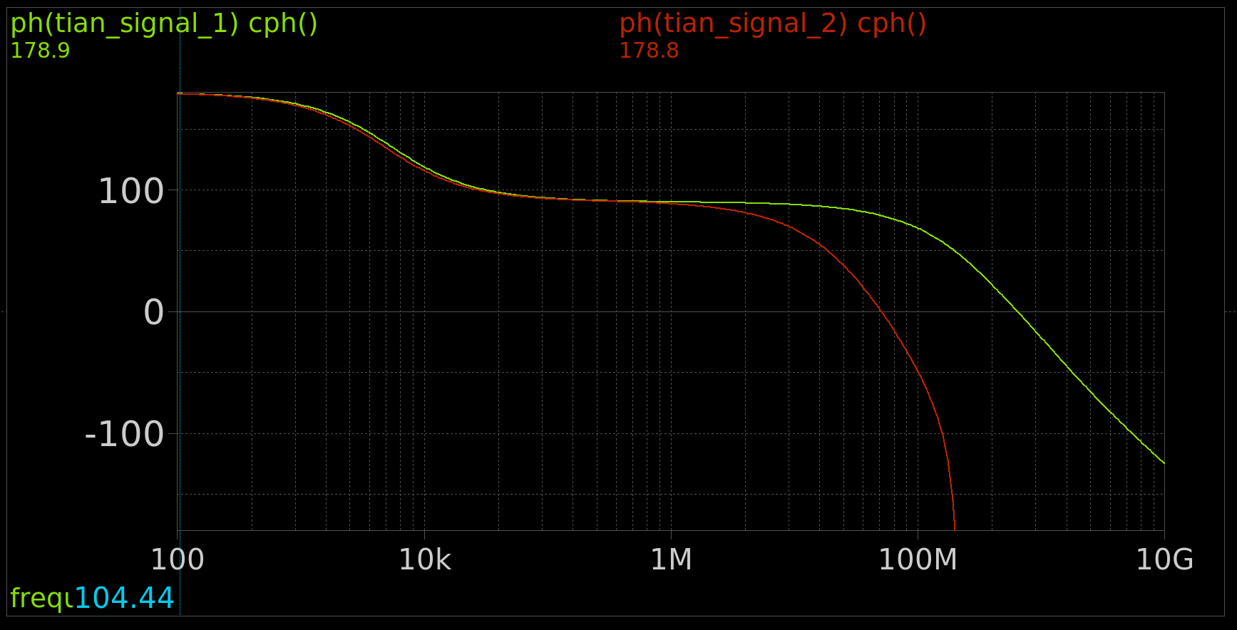
Figure 55 Phase for CM and Diff Feedbacks

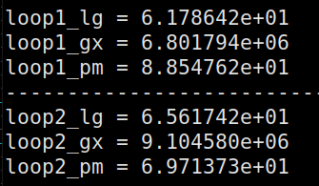
Figure 56 Circuit Parameters obtained from Simulation
 | Diff Loop | CM Loop
LG | 1216.18 | 1905.46
LG dB | 61.7 | 65.6
GBW | 6.8MHz | 9.1045MHz
PM | 88.547 | 69.713

• Compare GBW and PM of diff and CM loops. Comment.
Differential has less GBW but higher PM compared to CM, Making CM less stable

• Compare DC LG and GBW of the diff loop with those obtained from open-loop simulation. Comment
The AOL gain in the Open Loop simulation was equal to 3847.1 which gives a LG third that equal to 1282.36 which is close to the value we get, It is a bit different due to the loading effect of the feedback that we don’t see in open loop, we tried to account for it though in the open loop simulation when designing the amplifier.
Due to the lower gain we also get lower GBW

PART 6: Closed Loop Simulation (Transient Analysis)
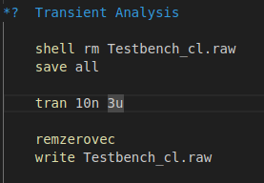
Figure 57 Transient Analysis Code

Differential and CMFB loops stability (transient analysis) + CL settling time: Differential input pulse:
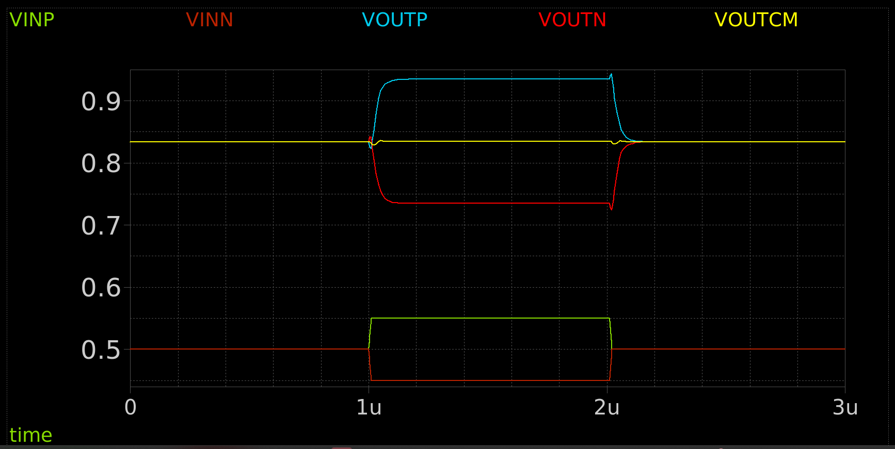
Figure 58 VINP VINN VOUTP VOUTN VOUTCM Overlaid
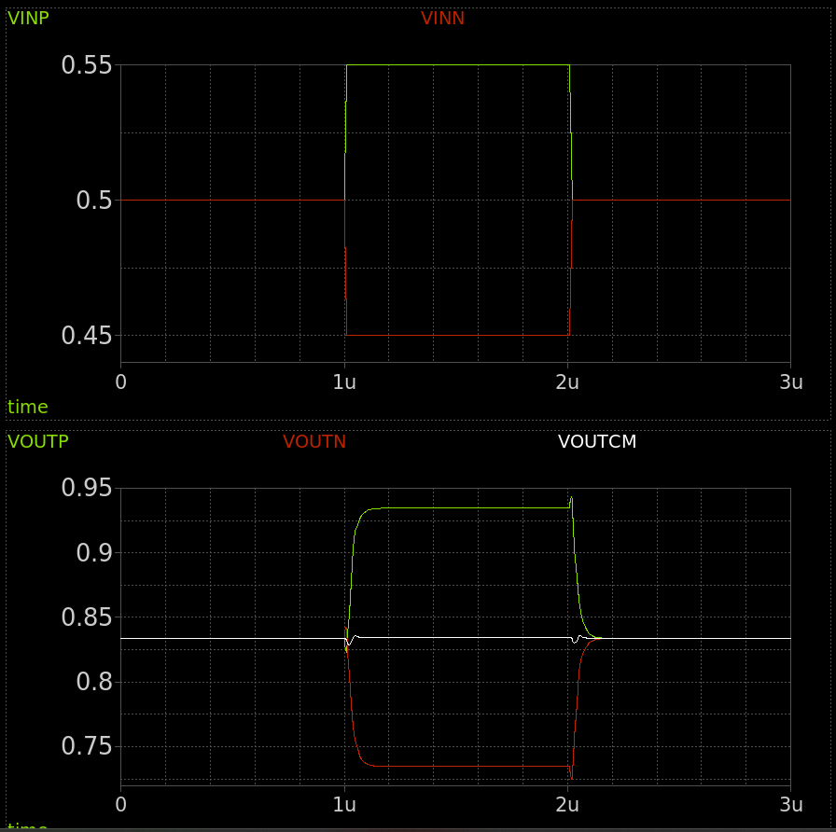
Figure 59 Inputs and Outputs Overlaid on Different Figures

• Do you notice any differential/CM ringing? Are both loops stable with adequate PM?
There is a little bit of barely visible ringing in CM due to its lower PM and none in Differential.
The spikes seen are caused by the capacitors in the circuit not allowing sudden changes.
Both have adequate PM that is within spec and doesn’t distort the signal too much.

• Calculate the 1% settling time and compare it to the required specification. If the specification is not satisfied, what design changes could be a possible solution?
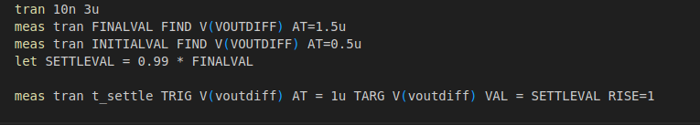
Figure 60 Code to Measure the Settling Time
I set the code to Trigger at 1u since this is when the signal starts getting injected into the amplifier as per the pulse.
Figure 61 Settle time from Simulation

Settle time is equal to 116ns which is slightly above spec.
It can be improved by improving the GBW which can be improved by increasing gain slightly (Increasing W of input Pair to increase its gm) or increasing current to increase BW

I decided to test by increasing the Gain, I increased the widths of the input pair as well as the lengths of the cascode devices.
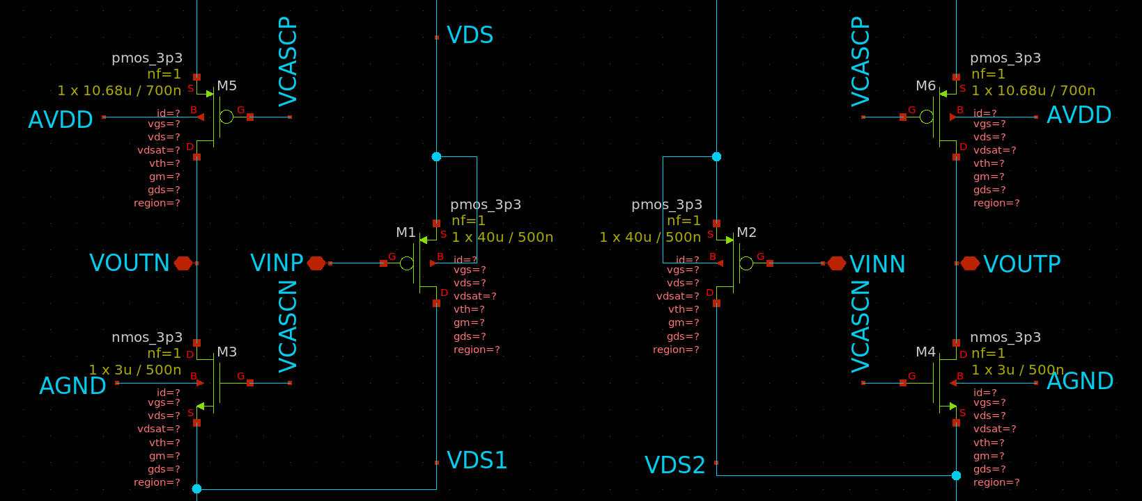
Figure 62 Adjusted Sizing for increased Settling time
Figure 63 Improved Settling Time

Differential and CMFB loops stability (transient analysis): CM input pulse:
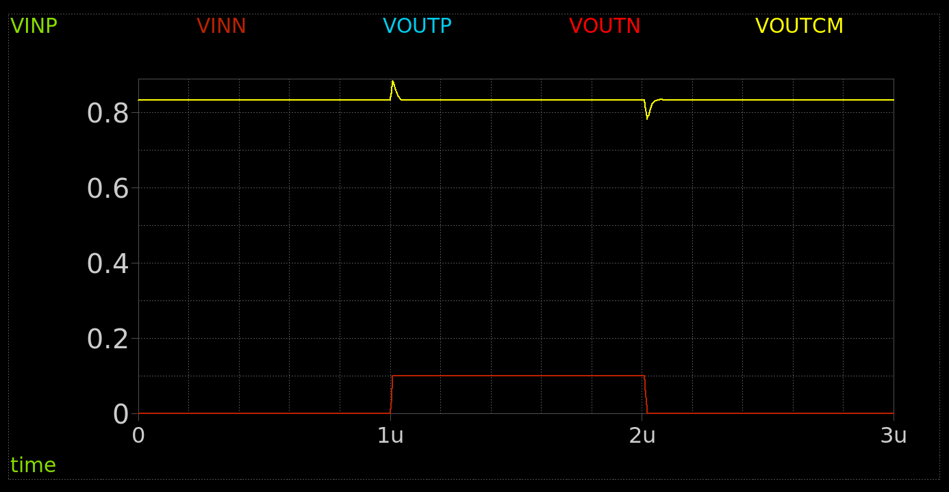
Figure 64 VINP VINN VOUTP VOUTN VOCM Overlaid on same figure
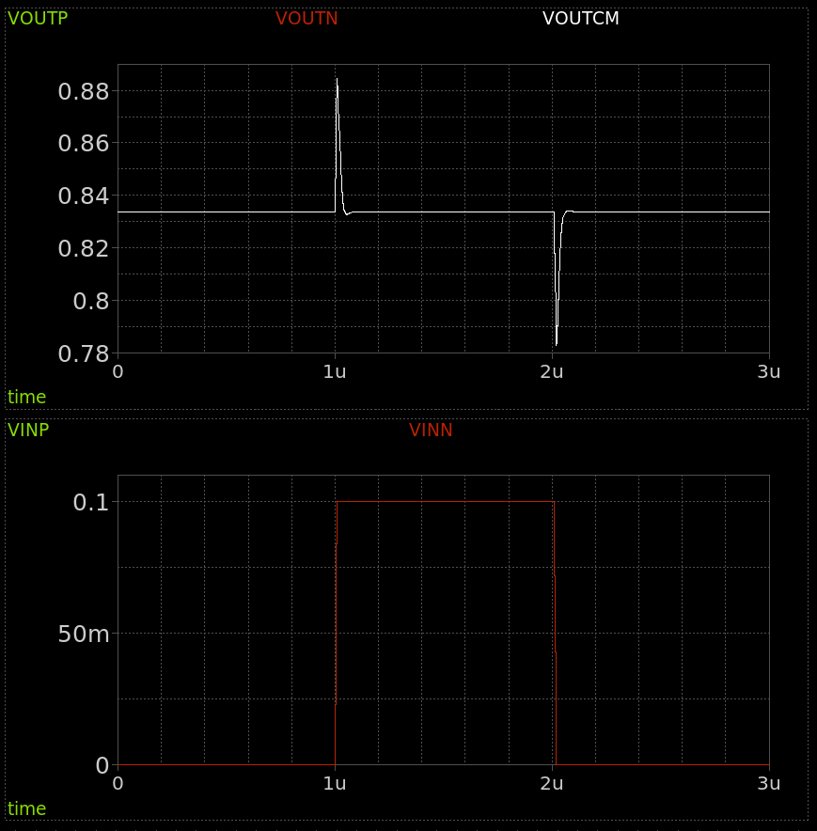
Figure 65 Inputs and Outputs Overlaid on Different Figures
Do you notice any differential/CM ringing? Are both loops stable with adequate PM?
There is a little bit of CM ringing barely visible other than that it seems decently stable.
The spikes seen are due to the capacitors not allowing sudden changes.
Both have adequate PM that is within spec and doesn’t distort the signal too much.

Output Swing:
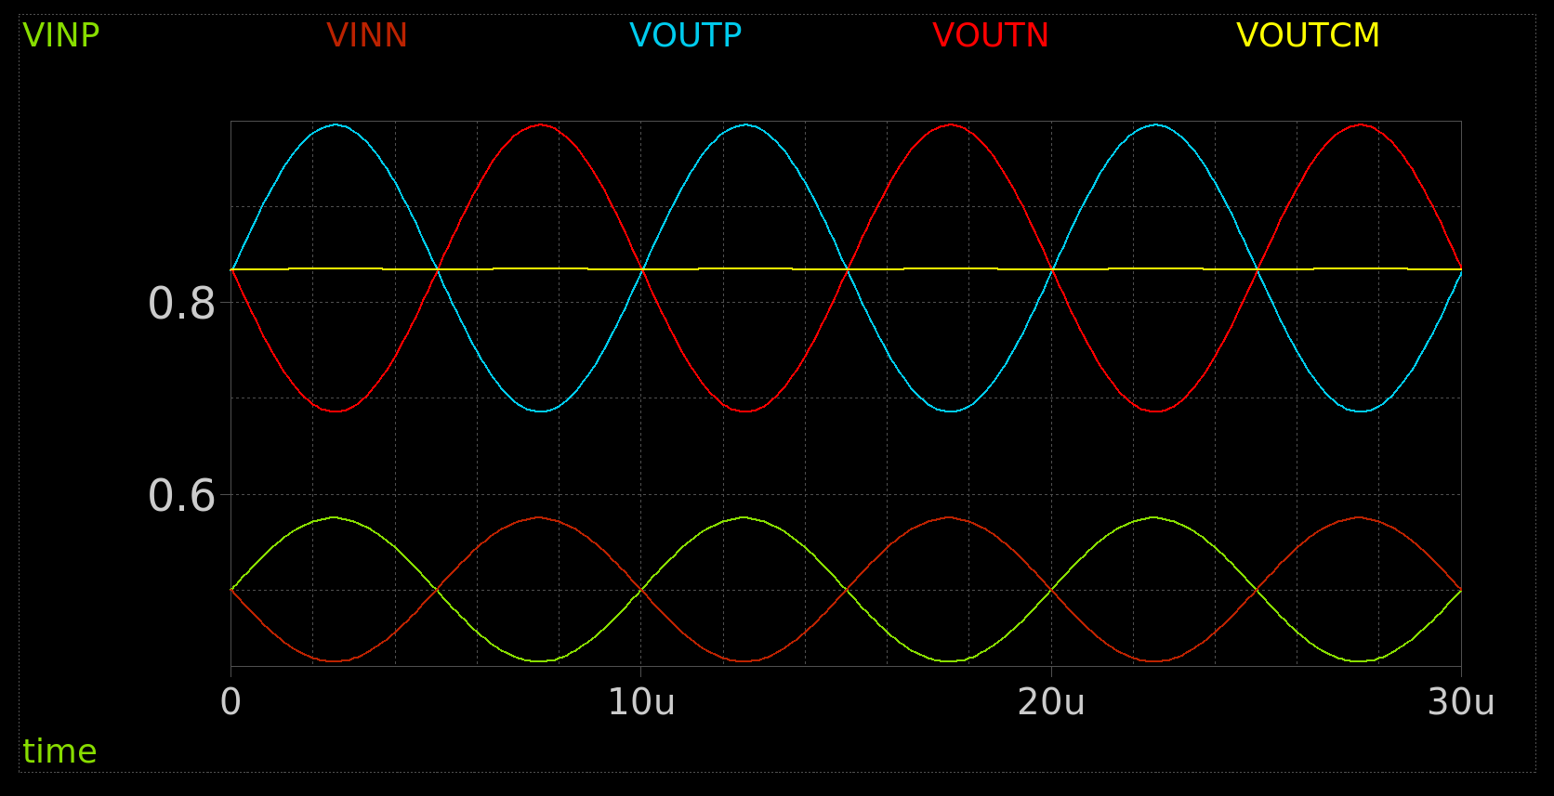
Figure 66 VINP VINN VOUTP VOUTN VOUTCM Overlaid
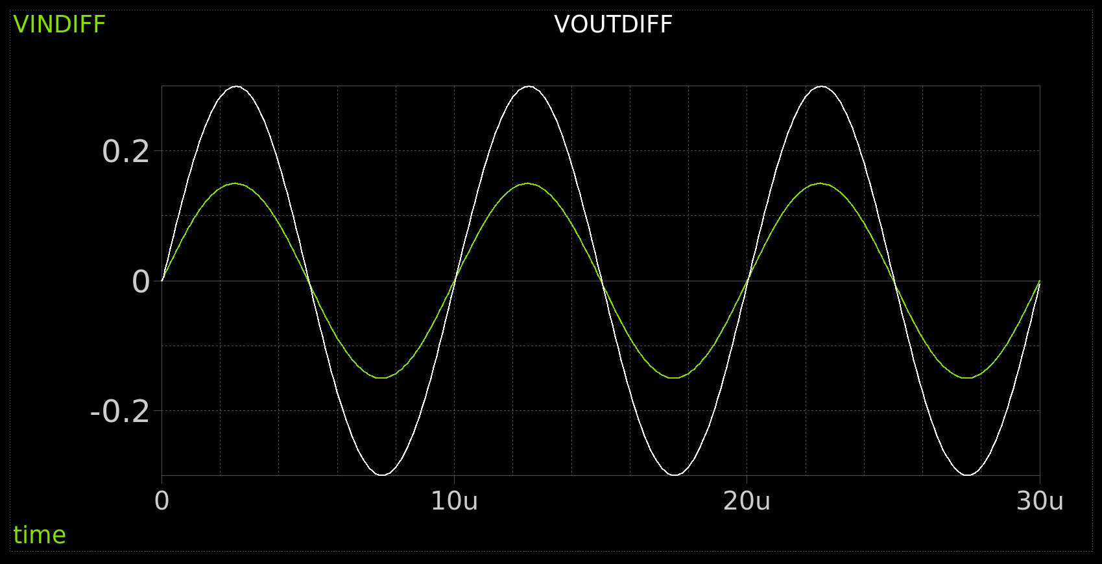
Figure 67 VINDIFF and VOUTDIFF Overlaid
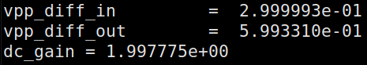
Figure 68 PeakToPeak Values and DC Gain

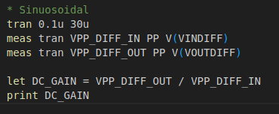
Figure 69 Code for the sinusoidal signal

